The Moon by Mary Barrett

The Moon is really just one size The light grows larger every day
It always stays the same, Exactly as it ought'er,
But here on Earth before our eyes, But logic tells us we must say
We see it wax and wane. What looks like half is quarter.

The new moon we don't see at all, And then there's gibbous on its way
But then there is a sliver, To full, the brightest face,
The crescent moon is what we call Then swiftly it begins to wane
This slice that makes us quiver. 'Til gone without a trace.

These changes happen every night;
Each month we see each phase

The moon intrigues us with its light
It truly does amaze.

Dear God,
It is great the way you always get the stars in the right place. Why can't you do that with the moon?
Jeff (a young child)

Point Value: The Moon Project is worth 150 points.

Purpose: This assignment is designed to give you the opportunity to…
• become intimately familiar with the various changes that the moon goes through each month and season.
• conduct a genuine scientific research project: to make systematic accurate observations and to use those observations to derive scientific conclusions WITHOUT “looking it up” somewhere.
• design and teach a lesson that guides others to discover scientific concepts for themselves.
• write a detailed teacher’s guide to show others how to teach about a particular science topic.

Overview of the Moon Project
You will be assigned to one of four topics (see pages MP–3 through MP–8 for detailed descriptions of the topics). Twenty times over three months, you will observe the moon and stars as appropriate for your topic. Then, as part of a team that consists of all of the students in your lab section assigned to your topic, you will use your observations and the scientific method to come to a scientific conclusion about the motions of the moon and Earth. You and your team will then design and teach a 45-minute lesson on your topic to the rest of the lab class.
Note that this is a group project, in part, but every member of the team must be actively involved and responsible. Every team member must fully understand the concepts. Every team member must play a vital role in the scientific discovery process and in the planning and teaching of the lesson. Most important, you will be individually responsible for all of your moon observations and for the graphs for your topic.

Organization of the Moon Project
Part of Project | Specific Requirements Described on Pages…
Observations and Graphs | MP–11 through MP–19
Teaching of the Lesson | MP–21 through MP–23
Teacher’s Guide | MP–25 through MP–31
Evaluations | MP–33 through MP–35

General Formatting Requirements for the Moon Project

• Submit your moon project in a thin 3-ring binder.
• Place the Grading Sheet (page MP–9 of this course packet) at the very beginning of your binder.
• Place all parts of the moon project (except for the team member evaluations) in the binder in the exact order listed on the Grading Sheet.
• Use tabs to subdivide and label each of the three main parts of your moon project.
• Use bold headings to mark the beginning of each subdivision within the three main parts of your moon project.
• Put a page number on each page.
• All text must be typed. Hand-drawn diagrams and graphs are, however, perfectly acceptable, as are hand-written data entries and completed evaluation forms.
Description of Topic #1: Moon Rise and Set
Questions to Answer:
1. We all know that the sun rises in the east and sets in the west. But what does the moon do? Does it rise in the east and set in the west (like the sun does)? Or, since we know that the moon revolves around Earth from west to east, does the moon rise in the west and set in the east (the opposite of what the sun does)? Prove your answers using your observations. Explain WHY the moon rises where it does and sets where it does.
2. The sun always rises in the morning and sets in the evening. The moon, on the other hand, rises and sets at any and all times of the day or night. Why? Is there any pattern to the changes in the times of moon rise and set? What is that pattern? Why does that pattern exist?
3. Is there any correlation between the times of moonrise/moonset and the phases of the moon? If so, clearly explain that correlation and explain and illustrate WHY this correlation exists.

Hints For Figuring Out the Answers to Your Questions: Fill in the blanks below. Can you draw similar diagrams for other positions of the moon? Why do east and west seem to be in opposite directions on the two diagrams? How do these diagrams relate to your topic questions?

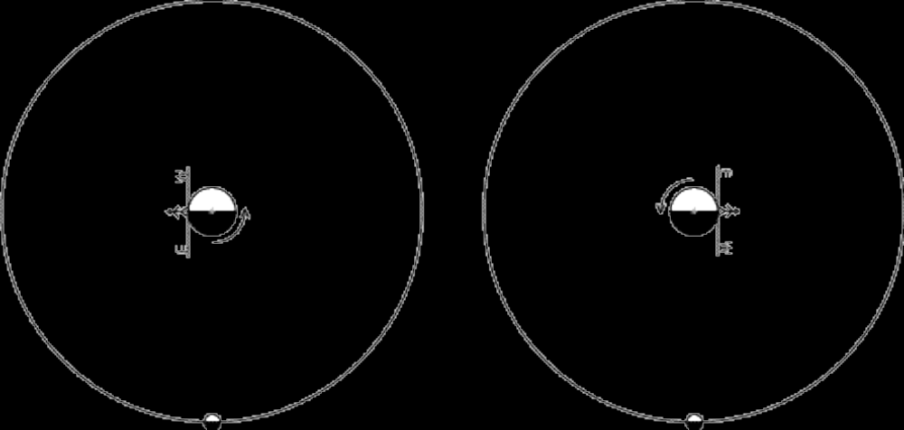 Moon rise / set Moon rise / set
Approximate Time of Day Approximate Time of Day
Phase of the moon Phase of the moon

Description of Topic #2: Angle of Tilt of the Moon

Questions to Answer:
1. The angle of the lit portion of the moon relative to the horizon changes. For example, sometimes the crescent moon looks like a crooked smile ( ); other times it looks like a hat cocked at an angle ( ). The lit portion of the moon doesn't really rotate, so why does it look like it does? What is REALLY happening?
2. As the moon makes its arc across the sky, how many degrees does the lit portion seem to rotate per hour?
3. The pattern made by the lunar maria (see Fig. 22.3 on p. 629 of your textbook) is always the same but it is not always at the same orientation—sometimes the “rabbit in the moon” is right side up; sometimes it is upside down. Why does this pattern of lunar maria appear to change orientation?

Hints For Figuring Out the Answers to Your Questions: In the diagram below, the moon is on the left and Earth is on the right. You are looking down on the North Pole. The diagram shows one person standing at the equator and moving with Earth as it rotates on its axis. The person is shown in four different positions, six hours apart. One time is at moon rise, one is at moon set, one is at the point when the moon is directly overhead, and one is when the moon is not out at all. Which is which? What does the moon look like to that person at each time? What phase is it in? Does the moon appear to be lit on the top, bottom or side? Over the 12 hours that the moon is out, which way does the moon appear to rotate? How would all of this look different to a person at 40° N. latitude (i.e. the latitude of Chico)?



Description of Topic #3: Length of the Moon “Day”

Questions to Answer:
1. We all know that the sun is up much longer each day in the summer than it is in the winter. The length of time that the moon is up each “moon day” also varies. Describe how and why the length of the moon day varies over the course of one moon cycle.
2. Every day, the moon follows an arc-shaped path across the sky. It first appears at the horizon, then gradually rises up as it travels across the sky. At the half-way point, the moon reaches a maximum altitude (height above the horizon) for that day. Beyond the half-way point, the moon sinks lower and lower as it continues to travel across the sky until, finally, the moon drops out of sight below the horizon. The maximum altitude reached by the moon is not the same every day. Some days it’s so high, you have to crane your neck to see the moon; other days, it’s only about a third of the way up from the horizon.
Describe how and why the daily maximum altitude (height of the moon above the horizon) varies over the course of one moon cycle.
3. The moon is out longest during different phases at different times of the year. For example, sometimes the moon is out longest during the full moon phase but sometimes the moon is out longest during the waxing crescent phase, etc. There is a definite pattern to the month of the year and which phase of the moon is out longest; clearly and fully describe this pattern and explain why this pattern exists.
4. The maximum daily altitude of the moon varies in a systematic way with regard to moon phase and season. For example, in December, the full moon gets very high in the sky but in June the full moon never gets very high above the horizon. Explain how and why this is true, giving specific examples for each season.

Hints For Figuring Out the Answers to Your Questions over ⇒
Hints For Figuring Out the Answers to Your Questions: The diagram below shows moon rays coming toward Earth from a moon that is toward the right, beyond the edge of the paper. This diagram also shows the horizon for a person standing at 40°N Latitude on the side of Earth that can see the moon. Note the angle between the moon rays and the horizon. The curved line is the path that this person takes (even while standing still!) as Earth rotates about its axis. Note the line that splits this path. This line divides the part of Earth that can see the moon from the part of Earth that cannot see the moon. Can the person at 40° latitude see the moon for more than 12 hours/day or less than 12 hours/day. How do you know? Now, think about where the sun is. What if the sun were also toward the right but WAY beyond the edge of the paper. What phase is the moon in? How do you know? What season is it? How do you know?

What if the moon were on the left side of Earth and the sun were still on the right side? How would your answers to the above questions be different? How would you redraw the diagram to fit this situation?

What if the sun were on the left? How would your answers to the above questions be different?
What if the moon were hovering in the air above the paper (near where your head is now), shining down on Earth? How would your answers to the above questions be different?
What if the moon were down underneath the paper (near where your feet are now), shining up toward Earth? Again, how would your answers to the questions be different?

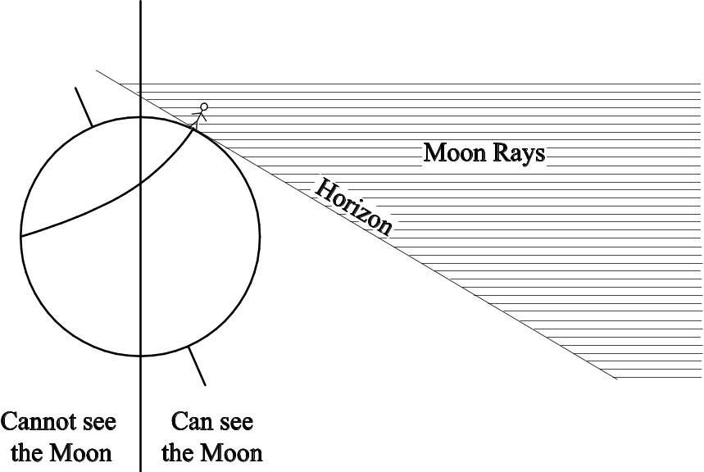

Hint for the “why?” parts of all of the questions: The 5° tilt of the moon's orbit around Earth has a slight influence on the length of the moon day and height of the moon in the sky, but it is not the main influence. Thus I suggest you ignore this effect completely. There's another bigger influence; focus on that.
Description of Topic #4: Synodic and Sidereal Months

Questions to Answer:
1. The amount of time that the moon is out on any given day (or night) varies considerably. In Chico, the amount of time the moon is out ranges from 9 hours to 16 hours (See the table on entitled “Moon Facts for the Year 2008”).
We know that the sun is out the longest on the summer solstice (± June 21). After that date, the days gradually get shorter and shorter until the winter solstice (± December 21), the shortest day of the year. After the winter solstice, the days gradually get longer and longer until the next summer solstice. In scientific terms, the number of hours that the sun is out increases and decreases in a cycle with a periodicity of one year.
The number of hours that the moon is out also increases and decreases in a cycle. What is the periodicity of that cycle? Is it one synodic month? One sidereal month? One year? Or something else altogether? Use one of your graphs to prove your answer. Why does that cycle have the length that it does? Draw diagrams to illustrate your answers.
2. What do the longest moon days of all moon cycles have in common (this should “fall out” of one of your graphs)? Why? What do the shortest moon days of all moon cycles have in common? Why? What do the average-length moon days of all moon cycles have in common? Why? Draw diagrams to illustrate your answers.
3. The moon, like the sun, travels through the constellations of the Zodiac. How long does it take the moon to go through all of the constellations of the Zodiac? Does it take a synodic month? A sidereal month? A year? Or something else altogether? Why?
4. How do we know that it takes the moon exactly 27 1/3 days to complete a 360° orbit of Earth (a sidereal month)? Hint: one of your graphs should provide the information you need.

Hints For Figuring Out the Answers to Your Questions over ⇒

Hints For Figuring Out the Answers to Your Questions: The diagram below shows moon rays coming toward Earth from a moon that is toward the right, beyond the edge of the paper. This diagram also shows the horizon for a person standing at 40°N Latitude on the side of Earth that can see the moon. Note the angle between the moon rays and the horizon. The curved line is the path that this person takes (even while standing still!) as Earth rotates about its axis. Note the line that splits this path. This line divides the part of Earth that can see the moon from the part of Earth that cannot see the moon. Can the person at 40° latitude see the moon for more than 12 hours/day or less than 12 hours/day. How do you know? Now, think about where the various Zodiac constellations are. In the diagram below, what is the astronomical place of the moon, relative to these constellations? How do you know?
What if the moon were on the left side of Earth? How would your answers to the above questions be different? How would you redraw the diagram to fit this situation?
What if the moon were hovering in the air above the paper (near where your head is now), shining down on Earth? How would your answers to the above questions be different?
What if the moon were down underneath the paper (near where your feet are now), shining up toward Earth? Again, how would your answers to the questions be different?

 | Checklist  (Place in order listed) |  | Point Value | Your Points | Instructor Comments
Part 1— Observations and Graphs |  | General Observations | 30
Part 1— Observations and Graphs |  | Observations Specific to Your Topic | 30
Part 1— Observations and Graphs |  | Graphs | 30
Part 2— Teacher’s Guide |  | Background Information | 100
Part 2— Teacher’s Guide |  | Time Management | 100
Part 2— Teacher’s Guide |  | Pre-Lesson Preparation | 100
Part 2— Teacher’s Guide |  | Step-by-Step Instructions for Teaching Lesson | 100
Part 2— Teacher’s Guide |  | Student Handout | 100
Part 2— Teacher’s Guide |  | Answers to Questions on Student Handout | 100
Part 2— Teacher’s Guide |  | Citations | 100
Part 3— Evaluations |  | Evaluations by Classmates | 30
Part 3— Evaluations |  | Evaluation by Lab Instructor
Part 3— Evaluations |  | Your Evaluation
 |  | Team Member Evaluations
 |  | Total Points:

Instructions for All Topics (See also instructions for your specific topic)
Due Date: The observations and graphs will be due in the middle of the semester, BEFORE the rest of the moon project is due. See your syllabus for the exact date.
What to Hand In: Your original completed moon observation tables (pp. MP–49 through MP–62 of this course packet) and your completed graph(s) for your topic (pp. MP-67 through MP-91).
Where to Make Your Observations: The best place to make each observation is in a large open area (a sports field or large parking lot, for example).
Required Number of Observations: You must observe the moon, focusing on the specific observations required for your topic, on at least 20 different dates (Depending on your topic, you may have to observe the moon several times on the same day). At least 7 of these observations must be made during the waning phases of the moon. BEGIN YOUR OBSERVATIONS IMMEDIATELY. Don’t wait until there are only 20 days left until the due date.
Data to Record: Record your data in the table entitled “Table of YOUR Moon Observations” and on separate paper as needed. EVERYONE should record the data described below. IN ADDITION, record data specific to your topic as described in your topic description.
1. Record the time of each observation. Be sure to include a.m. or p.m. as appropriate.
2. Under “Sketch of Moon,” sketch the moon the way you see it in the sky by blackening the part of the moon that you can NOT see; leave the visible part of the moon white. Be sure to clearly show how the visible portion is “tilted” relative to the horizon (on the data table, imagine the horizon as a horizontal line on the bottom of the page).
3. If it is cloudy out or if you forget to look, make a note of that, but do not sketch the moon unless you actually observe it and do not record any observations that you have not personally made of the real sky (the internet is NOT the real sky). The worst sin that a scientist can commit is to falsify data. Do not commit this sin! Don't laugh–students try it every semester and end up being very disappointed in their moon project grades.
4. Record your observations as neatly as possible. But neatness is much less important than honesty, thoroughness, accuracy and usefulness. For an example of an observation table made by the great scientist, Galileo, see Figure 21.15 on p. 609 in your textbook.
Suggested Times of Observations: Be sure to make each observation when the moon is actually out. The time period when the moon is out varies from day to day. Use the moonrise and moonset times, stated in the “Table of YOUR Moon Observations,” to figure out when you will be able to see the moon each day. Depending on your topic, some observation times will be better than others; see the description of your specific topic for details.
Specific Instructions for Topic #1: Moon Rise and Set
What to Hand In:
1. Extra Data Tables for Topics #1 and #2—Two Observations on the Same “Moon Day”(pages MP–63 to MP–64 of this course packet)
2. Graphs for Topic #1 (pages MP–67 to MP–72) of this course packet)

Observations to Make
1. For EVERY general observation you make (see page MP–11), note the compass direction of the moon (is it in the NE, E, SE, S, SW, W or NW part of the sky?). To assure accuracy, use a compass and/or refer to a map.
WARNING: In Chico, the streets are “crooked;” they are NOT lined up with N, S, E and W.
2. On at least 10 days (or nights), observe the moon twice on the same “moon day,” at least four hours apart. In other words, after a given moon rise, observe the moon twice before it sets again. Each time, draw the moon exactly as you see it, record the position of the moon in the sky (relative to N, S, E, W and “up”) and make a sketch of the trees and houses in the foreground. Put all of this information in the table entitled “Extra Data Tables for Topics #1 and #2.”

Use the given moonrise and moonset times on the “Table of YOUR Moon Observations” to determine good dates and times for making your double observations at least four hours apart. For example, on Sunday, September 7th, you will be able to see the moon most of the afternoon and evening. You could observe it at 4:00 p.m. and then again at 10:00 p.m.

The longer the time lapse between your observations, the better, but it is sometimes hard to find the moon in the middle of the day. So watch for opportunities to make two observations in the dark. For example, on Monday, September 15th, you could observe the moon at 10:00 p.m. and then a second time when you wake up Tuesday morning (September 16th) at 7:00 a.m.

Note that both observations may or may not be on the same calendar date. That doesn't matter as long as both observations are made on a single “moon day” (between a single moonrise and the next moonset).

What to Graph:
The table entitled “Moon Facts for the Year 2008” lists times of moonrise and moonset for each date in the year 2008. Use the data on this table to complete the graph for Topic #1, depicting the time when the moon is out for each date between September 1 and December 31, 2008. If you are confused as to how to complete this graph, see the example graph for Topic #1 on page MP-68.

A word to the wise: Complete your graph as early as possible and have your lab instructor check it. You already have all of the data you need to complete the graph. The completed graph will help you understand your topic better.

Specific Instructions for Topic #2: Angle of Tilt of the Moon

What to Hand In:
1. Extra Data Tables for Topics #1 and #2—Two Observations on the Same “Moon Day” (pages MP–63 to MP–64 of this course packet).
2. Extra Data Table for Topic #2 (page MP–65)—Six Observations on the Same “Moon Day”
3. Graphs for Topic #2 (pages MP–73 to MP–76 of this course packet)

Observations to Make:
a. Make the general observations, as described on page MP-11.
b. On at least 10 days (or nights), observe the moon twice on the same “moon day” (i.e. between a singe moonrise and the next moonset) at least four hours apart. In other words, after a given moon rise, observe the moon twice before it sets again. Each time, very carefully record the following on the “Extra Data Tables for Topics #1 and #2:”
(1) Record the position of the moon in the sky (relative to N, S, E, W and “up”) and make a sketch of the trees and houses in the foreground.
(2) Draw the moon so that the angle of the lit portion of the moon relative to the horizon is accurately shown. This can be difficult to do correctly if the moon is high in the sky. So be sure to always face the moon as directly as possible, then draw the moon as seen relative to the point on the horizon directly in front of you (i.e. the spot where you can draw an imaginary line straight up to the moon without going past the zenith or going sideways—see diagram below).
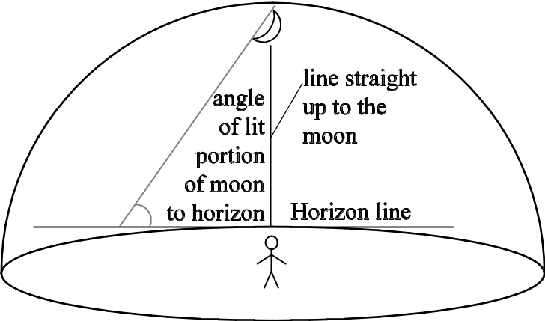
(3) Using a protractor, measure the angle of the lit portion of the moon relative to the horizon. Record this angle in the “Extra Data Tables for Topics #1 and #2.”
(4) Observe and illustrate the locations of the darker portions of the moon's surface, called the lunar maria (pronounced like the name “Maria,” except with the accent on the first syllable instead of the second).

Use the given moonrise and moonset times on the “Table of YOUR Moon Observations” to determine good dates and times for making your double observations at least four hours apart. For example, on Sunday, September 7th, you will be able to see the moon most of the afternoon and evening. You could observe it at 4:00 p.m. and then again at 10:00 p.m.

The longer the time lapse between your observations, the better, but it is sometimes hard to find the moon in the middle of the day. So watch for opportunities to make two observations in the dark. For example, on Monday, September 15th, you could observe the moon at 10:00 p.m. and then a second time when you wake up Tuesday morning (September 16th) at 7:00 a.m. Note that both observations may or may not be on the same calendar date. That doesn't matter as long as both observations are made on a single “moon day” (between a single moonrise and the next moonset).

c. On at least one day (or night), when the moon is shaped like a crescent or half circle, observe the moon at least 6 times on the same “moon day.” Wait at least one hour between each pair of observations. Each time you make an observation, carefully record all the data described under “b” above on the “Extra Data Table for Topic #2—Six Observations on the Same Moon Day.”

What to Graph:
1. Complete the graph of the “Angle of the illuminated portion of the moon to the horizon” vs. the “Time of day the Observation Was Made.” The angle values have already been written on the left side of the graph for you. But YOU must write in the appropriate observation times on the graph yourself; be sure to include “a.m.” or “p.m.” as appropriate. The bold lines on the graph should be one hour apart.
For example, if you made your first observation of the moon at 8:41 a.m. and the angle between the horizon and the illuminated portion of the moon was 22°, the graph would look like this; you would then add five more data points for the remaining five observations.
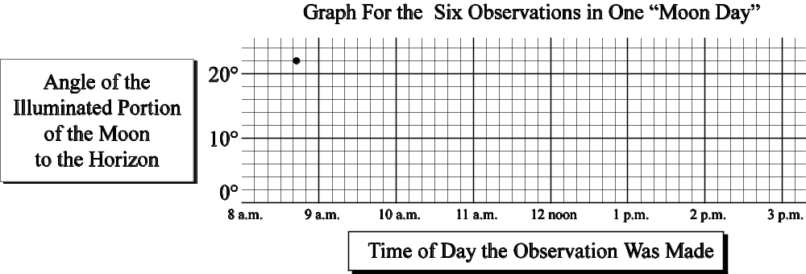

2. Complete the graph of the “Apparent Rotation of the Illuminated Portion of the Moon vs. the “Time Lapse Between Observations.” Do this as follows:
a. For each of the 10 times that you observe the moon twice in one “moon day,” measure the angle between the longest dimension of the illuminated portion of the moon and the horizon for both the “before” and “after” observations. The examples on the next page illustrate the method to use for both crescent and gibbous moons. Note that you should always measure the angle from the right. In other words, a moon that leans to the right will have an angle between 0° and 90°; a moon that leans to the left will have an angle between 90° and 180°.
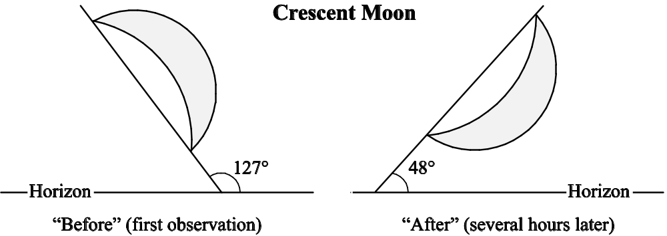
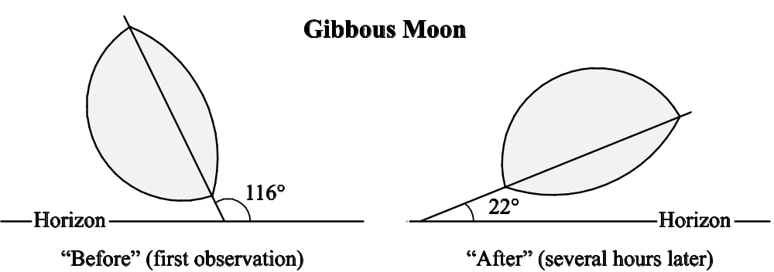
b. The moon doesn't really rotate, but it appears to. Measure the apparent angle of rotation of the illuminated portion of the moon that seems to have occurred between your two observations. The examples below illustrate the method to use for both crescent and gibbous moons.

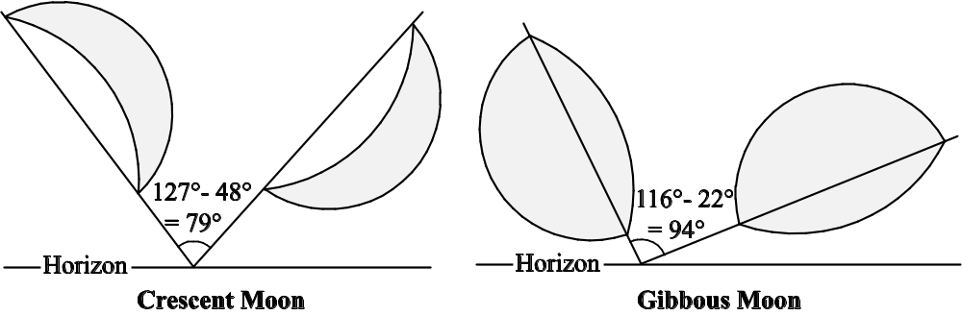

Crescent Moon: As shown above, the angle between the moon and the horizon was 127° at the time of the first observation; at the time of the second observation, the angle was only 48°. So the moon appears to have rotated 79° clockwise.
Gibbous Moon: As shown above, the angle between the moon and the horizon was 116° at the time of the first observation; at the time of the second observation, the angle was only 22°. So the moon appears to have rotated 94° clockwise.
c. Calculate the number of hours elapsed between your first and second observations. For example, if you took one measurement at 5:00 p.m. and one measurement at 12:00 midnight, the “Time Lapse Between Observations” was 7 hours.
d. For each pair of measurements, plot one data point on the graph for Topic #2 (“Amount of Apparent Rotation of the Illuminated Portion of the Moon” vs. “Time Lapse Between Observations”). The horizontal (X) axis point should be the amount of elapsed time between the two observations you made; the vertical (Y) axis point should be the apparent angle of rotation of the moon during that time.
e. When you have plotted all of your data points, see if there is any consistent relationship between the “amount of apparent rotation of the illuminated portion of the moon” and the “time lapse between observations.” Note: if the data points make a line, even if it is rough, then there IS a consistent relationship that can be approximated by drawing in a “best fit” line.

Specific Instructions for Topic #3: Length of the Moon “Day”

What to Hand In:
1. Extra Data Table for Topic #3—Altitude of the Moon at its Highest Point (page MP–66 of this course packet).
2. Graphs for Topics #3 and #4 (pages MP–77 through MP–88 of this course packet).
Observations to Make
a. Make the general observations, as described on Page MP-11.
b. At least five times (preferably more), time your observation so that you observe the moon near its highest point, half-way along its journey across the sky and half-way in time between moonrise and moonset. For each of these special observations, sketch the moon as usual and measure the altitude of the moon (the angle between the moon and the horizon—between 0° and 90°), following the procedure described on the next page. Record these data in the “Extra Data Table for Topic #3—Altitude of the Moon At its Highest Point.”
Make these special observations about a week apart and near the dates of the new, 1st quarter, 3rd quarter and full moon phases. Use the given moonrise and moonset times to determine good dates and times for observing the moon at its highest altitude for any given day.
For example, on Sunday, September 7th, the moon will be in its First Quarter phase. It will rise at 2:52 p.m. and set at 11:44 p.m. Thus, it will be up for a total of 8 hours and 52 minutes (see page MP-45). It will be at its highest point at 7:18 p.m., when it is exactly half way across the sky, 4 hours and 26 minutes after it rises.
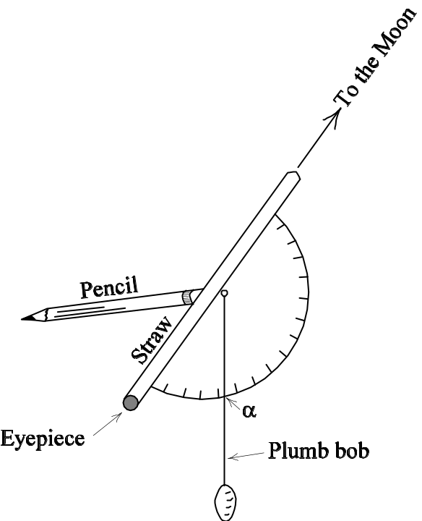
Here's another example: on Sunday, September 21st, the moon will be in its 3rd Quarter phase. It will rise at 11:22 p.m., stay up for 15 hrs, 56 min, and set at 3:18 p.m. the next afternoon. Thus the moon will be at its highest point at 8:20 a.m., 7 hrs, 58 min after it rises.
How to Measure the Altitude of the Moon: We will make and use a very simple instrument called a theodolite; materials will be provided in lab.
To construct the theodolite, tape a drinking straw to the straight edge of a protractor as shown in the adjacent diagram. Place the eraser end of a pencil against the hole in the protractor and insert a pushpin through the other side of the hole into the eraser—the pencil serves as a convenient handle. Next, tie a plumb bob (a string attached to a weight) to the needle part of the push pin.
To use the theodolite to measure the altitude of the moon, look through the straw at the moon, holding the straw as steady as possible. Let the plumb bob hang freely. Have a partner read the angle (we’ll call it α) through which the string passes. Or, if you are alone, let the plumb bob hang freely as you look at the moon. Then, hold the string in place against the protractor as you lower it and read the angle.
The altitude of the moon will be 90° - α.

What to Graph: The table entitled “Moon Facts for the Year 2008” lists the length of the moon day (# of hours the moon is up) for each day this year. Use the data on this table to complete the (six-page!) graph of the “# of Hours the Moon is Out.”

A word to the wise: Complete your graph as early as possible and have your lab instructor check it. You already have all of the data you need to complete the graph. The completed graph will help you understand your topic better.

Specific Instructions for Topic #4: Synodic and Sidereal Months

What to Hand In:
1. As part of your original completed moon observation tables (pages MP–49 through MP–62 of this course packet), show the stars around the moon on at least 10 dates. Place a red star next to those observations.
2. Graphs for Topics #3 and #4 (pages MP–77 through MP–88 of this course packet).
3. Graphs for Topic #4 (pages MP–89 to MP–92 of this course packet).

Observations to Make:
a. Make the general observations, as described on page MP-2, that each person must make, regardless of topic.
b. Whenever you observe the moon at night (at least 10 times), try to figure out what constellation the moon is “in” (use your Star and Planet Locator). In the far right column of the “Table of YOUR Moon Observations,” show the moon and any stars (or planets) that you see around the moon, whether or not you can recognize the constellation. Note: it is easiest to see the stars around the moon when the moon is a crescent. Try to time your 10 observations accordingly.

What to Graph:
a. You will plot the astronomical “place” of the moon for each date between September 1 and December 31, 2008. Get this information from the table entitled “Moon Facts for the Year 2008.” Plot this information on the graph entitled “Astronomical ‘Place’ of the Moon.”
b. The table entitled “Moon Facts for the Year 2008” also lists the length of the moon day (# of hours the moon is up) for each day this year. Use the data on this table to complete the (six-page!) graph of the “# of Hours the Moon is Out.”
c. On your graph of the “# of Hours the Moon is Out,” label the astronomical “place” of the moon next to each data point representing each of the following:
i. an average-length moon day (≈ 12 1/2 hours).
ii. the longest moon day of a cycle (this will show up as an obvious “hump” on the graph)
iii. the shortest moon day of a cycle (this will show up as an obvious low spot on the graph)
A word to the wise: Complete your graphs as early as possible and have your lab instructor check it. You already have all of the data you need to complete the graph. The completed graph will help you understand your topic better.

General Expectations for the Design of the Lesson
• The lesson is designed to be constructivist and discovery-based. In other words, design the lesson so that, by doing the activities, students construct for themselves the concept that you are trying to teach. If you feel the need to explain the concepts to the students, do so only AFTER students perform the activities, not before. Do not “give away” the answers; help students discover them.
• Hands-on activities play a central role; they accurately demonstrate the concept you are teaching.
• The lesson is structured so that the students are actively engaged, and thinking hard about the concept.
• Explore the concepts in depth, do not just give them a superficial treatment.
• The focus of the lesson is on the questions I ask in the topic descriptions; cover all the questions in the lesson. The emphasis is on important concepts—“big ideas,” not trivia.
• The lesson focuses on the understanding of concepts, NOT the learning of vocabulary. The lesson is free of vocabulary-centered activities such as word.
• The lesson requires the students to work with one or more of the graphs that you constructed for your moon project. The students are not asked to go through the tedium of making a graph, but to interpret the meaning of the completed graph.
• Design the lesson for the adults who have completed the astronomy portion of GEOS 342, NOT for children. It should be designed so that students discover and actively construct an understanding of the concepts by building on what they have already learned in this class.
• The lesson displays your creativity; it is not just lifted from teaching materials written by others.
• The lesson is a new experience for the students, i.e. DON'T teach concepts that the students have already learned in this class and, especially, DON'T have students repeat the exact same lab activities they have already completed earlier in the semester—you MAY, however, use the same materials and you may even do a slight variation on a previous lab activity IF the goals of the activity are different and IF you have the students answer different questions about the activity.
However, it is perfectly fine (recommended, even) to ask some quick warm-up review questions at the beginning of the lesson to make sure that the students have a solid correct foundation on which to construct their new understanding.

Student Handout

Together with your team mates, prepare professional-quality handouts for the students. Make enough copies for every student in the class. This student handout should have the same format as the lab activities in your course packet. Include ALL of the following sections (in this order):
• Title: Capture the essence of your lesson in a short title.
• Authors: Include the names of all students who contributed to the design of the lesson.
• Objectives: These are your goals for what the students will be able to DO after completing the lesson. In stating your objectives, use action verbs such as define, describe, explain, relate, compare, evaluate, identify, distinguish, interpret, and classify. It should be possible to achieve the stated learning objectives by completing the lesson; the objectives match the focus of the activities and questions.
• Activities: This is the meat of the student handout. Design the activities as described above. Then provide full clear instructions and questions for each hands-on activity. Specifically, for each activity you should include (in this order)…
a. Title: Summarize in several words what the activity is about
b. List of materials: List all materials needed for the activity. This list should be specific as to numbers, sizes and amounts.
c. Activity: Provide detailed step-by-step instructions for the hands-on activity that you want the students to do. These instructions should be clear, complete, and precise.
d. Questions: Write several well-thought-out carefully worded questions for the students to answer. These questions are a major component of this assignment. Give them a lot of effort. All questions should be…
• focused on constructing important concepts, not on repeating given information.
• specific, not vague. It should be very clear to the students what you are asking for.
• carefully sequenced to guide the students step-by-step down a line of reasoning that leads to a clear understanding of the concept you are trying to teach. In other words, for each concept, write several questions so that each question leads to the next one, guiding the students through a line of reasoning that culminates in a full understanding of the concept.
• carefully worded so that the students are actually able to answer them with some thought. In other words, the students should be able to figure out the answer based on what they observed in the activity itself, what they have already learned in this class, and any “mini-lectures” that you give them.
• Acknowledgments: specifically cite the source of each activity that is not your own original idea.

Teaching the Lesson
• You and your team mates (the other students in your lab class who are working on the same topic) will facilitate the lesson on your topic. Plan and coordinate carefully so each team member knows what s/he has to do and when.
• When none of you are speaking in front of the class, you should all be at the tables, helping the students work through the hands-on activities.
• Practice! Practice! Practice! Especially, be sure to practice any hands-on activities well ahead of time to be sure that they actually work.
• Understand the concept well enough that you can answer unexpected questions from students.
• Facilitate your classmates' progress throughout the activities; DO NOT do it for them.
• Make efficient use of your classmates' time. Do not require them to do “busy work” such as cutting, pasting, or doing simple repetitive calculations.
• Be sure there are plenty of hands-on materials for every lab table.
• Be sure to provide some type of “closure” to the lesson. In other words, make sure that the students leave the lesson with an understanding of the concept you were trying to teach.
• Your lesson must be 40-45 minutes long; no more, no less.

What is a “Teacher’s Guide?”
A teacher’s guide is a resource written for professional teachers that describes specific ways to teach particular concepts to students. A variety of teacher’s guides are available on many different topics. Some teacher’s guides are posted on the worldwide web; others are published in book form. When you become a teacher and/or parent, you will find these teacher’s guides to be invaluable resources. Some examples of published teacher’s guides on topics in astronomy include…
Astro Adventures, published in 1994 by the Pacific Science Center, Seattle, WA, (206)448-2627.
Earth, Moon and Stars, published in 1986 by Great Explorations in Math and Science (GEMS), Lawrence Hall of Science, Berkeley, California, http://www.lawrencehallofscience.org/.
Moons of Jupiter, published in 1993 by Great Explorations in Math and Science (GEMS), Lawrence Hall of Science, Berkeley, California, http://www.lawrencehallofscience.org/.
Project Earth Science: Astronomy, published by the National Science Teachers Association, Arlington, Virginia, 1995, http://www.nsta.org/index.html.
The Universe at Your Fingertips, published by the Astronomical Society of the Pacific, San Francisco, California, 1995, http://www.astrosociety.org/
All of these teacher’s guides are on reserve in the library. Check them out. Look them over. Get a feel for the type of document we’re asking you to write. By the way, just in case you think you are not qualified to write a teacher’s guide on a science topic, consider this: the best teacher’s guides on science topics are all written by classroom teachers, NOT by research scientists. Teachers know what works in the classroom. Research scientists (with a few rare exceptions) do not.

What must be included in the Teacher’s Guide?
1. Background Information: VERY IMPORTANT! This section fully answers the assigned questions about your topic (pages MP-3 through MP-7). It is a detailed explanation of the concepts that the students should know when they complete the lesson (NOT just a summary the concepts they should already know coming into the lesson). This section should consist of…
• A detailed text that explains ALL of the concepts you want the students to learn. This text should fully spell out the conclusions you want the students to arrive at by the end of the lesson. It should be several pages long and be in paragraph format; it is NOT a mere list of topics or objectives. This is where you should answer the questions relating to your topic.
• Well-designed conceptual diagrams (drawn by YOU, not just copied from somewhere else) that elucidate the concepts you explain in the text. These drawings are VERY IMPORTANT! It is impossible to make your explanations clear to the reader without such drawings.
Specifically refer to these drawings in the text of your “background information.” If you need help constructing a drawing, use the “hint” drawings for your topic as a starting point.
2. Pre-Lesson Preparation: Describe everything the teacher must do before the lesson begins.
• Include a specific list of all required materials, broken down as follows: (1) for the class, (2) for each small group of students, (3) for each individual student. The GEMS units do an especially good job of documenting the required materials for their lessons; see them for examples.
• Include copies of any graphs and/or data tables you had the students work with.
• Be especially sure to fully document how to construct any manipulatives or other hands-on materials that you or your team has designed for the lesson. Include photographs, assembly instructions, scale drawings, originals to be photocopied--whatever a teacher would need in order to construct these manipulatives for themselves. Explain where to obtain hard-to-find materials. The GEMS units describe pre-lesson preparation procedures very well; see them for examples.
3. Time Management: State the required time for each part of the lesson, including any short lectures by the teacher, teacher-led demonstrations, hands-on activities, student presentations, and whole-class discussions. Make sure all planned activities fit into one 45-minute lesson.
4. Step-by-Step Instructions for Teaching the Lesson: Describe what the teacher should do and say as the lesson progresses. Plan the lesson to flow logically, maximizing student learning and minimizing student frustration (i.e. students get what they need when they need it). Include detailed outlines of any lectures the teacher will give. The GEMS units give excellent step-by-step instructions; see them for examples.
5. Student Handout: This is a major part of your teacher’s guide. Carefully follow the format described on page MP-22. As necessary, modify the handout you actually used when you taught the lesson, incorporating suggestions from classmates and from your lab instructor as you see fit.
6. Answers to Questions on the Student Handout: Provide complete clear well-written and (as appropriate) well-illustrated suggested answers to all questions on the student handouts. The Project Earth Science teacher’s guide includes excellent examples of answers to questions for students; see this publication for examples.
7. Citations: Specifically cite the source of each part of the Teacher’s Guide that is not your own original idea. Make it ABSOLUTELY CLEAR which parts of the lesson were derived from the work of others (and who those others are) and which parts of the lesson resulted from your own efforts. A significant proportion of the teacher’s guide MUST BE YOUR ORIGINAL WORK.

Example Teacher’s Guide
(This is my teacher’s guide for the lab activity that you did on the Moon's Phases and Eclipses)

Background Information
Contrary to popular belief, the phases of the moon are NOT caused by Earth's shadow; lunar eclipses are (see below). Except during a lunar eclipse, the entire half of the moon that faces the sun is always fully illuminated by the sun. From Earth, we can only see all of the lit portion of the moon when Earth is directly between the moon and the sun; this is a full moon.
When the moon is directly between Earth and the sun, we on Earth can see none of the lit portion of the moon; this is a new moon.
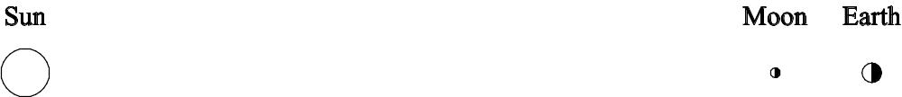
All of the other phases of the moon are partial views of the lit portion of the moon, i.e. we on Earth are viewing the lit portion of the moon more or less “from the side” as the moon revolves around Earth. See, for example, the depiction below of the 1st quarter moon.
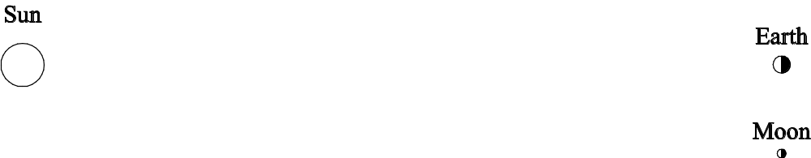
The moon revolves around Earth from west to east (counterclockwise when viewed from above the North Pole). We know this because, in the northern hemisphere, the right half of the moon is lit during the waxing phases of the moon and the left half of the moon is lit during the waning phases of the moon. If the moon revolved clockwise, we would see the left side of the moon lit during the waxing phases and the right side lit during the waning phases.
No matter what phase the moon is in, we can see from Earth, the same side of the moon always faces Earth. This is because the moon rotates exactly once every time it revolves around Earth.
An eclipse occurs when the moon, Earth and sun are in perfect precise alignment with each other. Such an alignment is rare and short-lived because these objects are very far apart. In addition, the moon's revolution around Earth is not in exactly the same plane as Earth's revolution around the sun; it is 5° off. As a result, Earth and the moon can pass through each other's shadows only twice each year; the rest of the time, they “miss” each other’s shadows. A lunar eclipse occurs when the moon passes through Earth's shadow. This can happen only during a full moon. Because Earth is much bigger than the moon, the entire moon can fit within Earth's shadow; thus everyone on the side of Earth facing the moon can see a lunar eclipse. When Earth passes through the moon's shadow, we have a solar eclipse; this can only happen during a new moon. Because the moon is much smaller than Earth, the moon's shadow only falls on a small portion of Earth's surface; therefore, only the people located in just the right spot will be able to see a solar eclipse.
Pre-Lesson Preparation
1. Well ahead of time, photocopy the “pop-up” moon diagram (see page MP-31) onto card stock. Using an Exacto knife, cut out each of the “skylights” along the three gray sides.
2. Ask the students to bring their moon observations to lab on this day.
3. Just before class, close all blinds and cover the windows in the doors. Set up these materials:
For the class:
• 100-Watt light bulb in a light fixture mounted on a heavy-duty stand, placed in center of room.
• Overhead projector, set up in the room next to the room.
• Overhead transparency of the “pop-up” moon diagram
• 10-12 blank overhead transparencies and several colors of overhead transparency pens
For each lab table:
• Photograph of the “near” side of the moon (one per lab table)
• Photograph of the “far” side of the moon (one per lab table)
For each student:
• 2 white polystyrene balls, one 3 inches and one 7/8 inch in diameter
• pencil
• pop-up moon diagram on card stock, cut as described above
• paperclip

Time Management
This lab takes one full lab period to complete (1 hour, 50 minutes). There is time to prepare presentations near the end of lab but there is not enough time to not to actually do them. The students can do their presentations at the beginning of the next lab period.

Part of Lab | Estimated Time Needed
Introductory Remarks | 5 minutes
Activity #1: Brainstorming | 5 minutes
Activity #2: Phases of the moon | 15 minutes
Activity #3: Direction of the moon’s revolution | 10 minutes
Activity #4: Completing the pop-up moon diagram | 15 minutes
Activity #5: Rotation of the moon | 10 minutes
Activity #6: Eclipses | 10 minutes
Activity #7: Why are eclipses so rare? | 10 minutes
End-of-Lab Thought Questions | 10 minutes
Preparing Presentations | 10 minutes
Step-by-Step Instructions for Teaching the Lesson
1. Introduce the activity: Tell the students that this is THE crucial lab that will start them on the road toward understanding their moon project topic. By the end of this lab, they should fully understand the phases of the moon and both types of eclipses.
2. Tell the students to begin Activity #1, the brainstorming activity. Tell them to take just a few minutes, taking turns within their groups, explaining their personal theories about what causes the moon’s phases, solar eclipses and lunar eclipses. As necessary, explain that a solar eclipse happens when the sun is not visible at a time when it should be, and a lunar eclipse happens when the moon is not visible (or is VERY faint) when it should be very bright. Tell the students to voice whatever ideas come to mind, to not censor them.
3. After the students have been brainstorming for 3-4 minutes, close all doors, turn on the light in the center of the room and turn off all other lights in the room. Get the students attention again. Tell them that it’s time to begin Activity #2.
Have each student pick up a 3” diameter polystyrene ball and a pencil. Tell them to insert the pencil into the hole in the ball. Then ask them to stand up, face the light in the center or the room and hold up their ball-on-a-stick at arm’s length, a foot or so above their heads, as shown on page C–18 of their lab. Tell the students that their heads represent the Earth and the white ball represents the moon. A person is living on their nose.
Tell the students that they will now cause the moon to have phases. Ask the students to slowly rotate, continuing to look at the ball as they hold it at arms length, a little higher than their heads. Watch for “Aha!” experiences.
4. Tell the students that they will now be asked to draw what they have seen in a 3-dimensional world onto a 2-dimensional piece of paper. They will have to make similar drawings throughout the Astronomy unit. Remind them that you can look at the same three-dimensional situation from many different directions and that each drawing made from a particular direction will look different from all the drawings made from any other directions. Point out that the drawing on page C–18 shows a view from the side but that, for questions 1a, 1b and 1c on pages C–18 and C–19, they will be asked to draw the same thing (with the sun added) as seen from above.
5. Turn students loose to work in groups at their own pace. Tell them to complete the questions for Activity #2 and then move on through the rest of the activities in the lab.
6. As students get to Activity #3, question #2, you may need to remind them to look at the moon observations they’ve been making for several weeks. They will need those observations to answer that question.
7. As students complete the pop-up-moon diagram (Activity #4), they usually make a lot of mistakes before getting it right. Suggest that they use pencils, not pens.
8. Students often have a hard time with Activity #5 because it’s hard for the human brain to see a perspective other than its own. It may be helpful to demonstrate this activity with the whole class. Get two volunteers to play the roles of the moon and Earth. Guide them through the activity, using the directions in the lab. Once most students in the class have understood, tell them to work in their groups, each taking a turn playing each role until they can clearly see that the moon must rotate once every time it revolves.
9. During Activity #6, students who have seen a lunar eclipse will often ask why the moon is a dim orange rather than pure black during the eclipse. Explain that, even though Earth is blocking 99+% of the sun’s light from illuminating the moon, a small amount of sunlight does reach the moon because Earth’s atmosphere (around the outside edges of Earth) refracts (bends) the light toward the moon. Red light bends more than blue light (which is why you can separate colors with a prism) so more red light makes it to the moon than does blue or yellow.
10. When most students get to Activity #7, get all of the students' attention and demonstrate the 5° tilt of the moon's orbit by walking around the room (to show Earth's revolution around the sun) while simultaneously revolving a polystyrene ball-on-a-stick (in one hand) around an Earth ball (in the other hand). Hold the “moon” so that the stick is ABOVE the ball; this allows you to revolve the “moon” around the “earth” without bumping one arm into the other. Make sure the moon’s orbit is not horizontal and is consistently above the “Earth” when it’s on one side of the “Earth” and below the “Earth” when it’s on the other side.
11. The end-of-lab thought questions really make the students think, especially #2. Many students don’t fully grasp what makes the SUN rise and set, let alone the moon. When students get stumped by this question, have them first model the rise and set of the sun, rotating their bodies (and heads), modeling Earth’s rotation about its axis. The students should again imagine a person living on their nose. Point out that, for that person, their left cheek is east and their right cheek is west (which seems backwards because they are on the inside of Earth looking out instead of their usual perspective when looking at a map).
12. Near the end of the lab period, assign presentations to each group. Hand out overhead transparencies with assignments written on them. Do presentations at the end of the lab period if possible. Otherwise, have students prepare their overhead transparencies and hand them in, beginning the next lab period with presentations.
Group 1: Activity #
Group 2: Activity #3
Group 3: Activity #4 (give this group the transparency of the pop-up moon diagram)
Group 4: Activity #5
Group 5 Activities #6 and #7
Group 6: End-of-Lab Thought Questions

Student Handout: See pages C–17 through C–26.

Answers to Questions on the Student Handout:
We will hand these out AFTER you have completed the lab on the moon’s phases and eclipses (we wouldn’t want to spoil the fun of discovering those answers for yourself!)

Citations: See footnotes on the bottoms of pages C–18 and C–23.

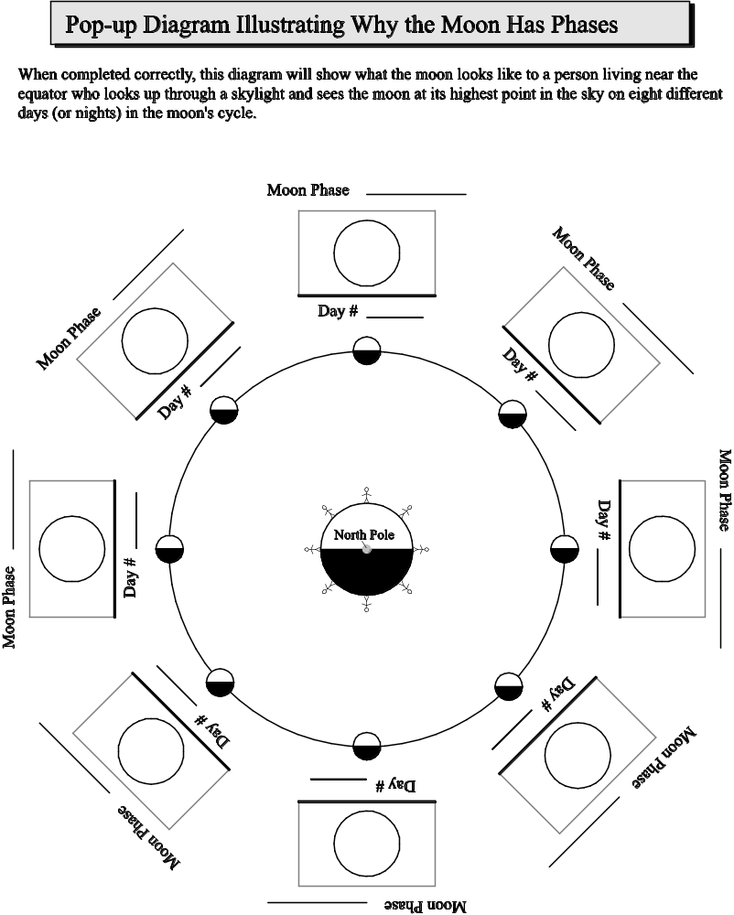

Evaluations by Classmates
• After your lesson, ask the class to evaluate your team’s lesson (evaluation forms for this purpose will be handed out in class). Include at least five of these evaluations in your moon project.
• This part of the moon project is credit/no credit. You receive credit if you include at least five evaluations; you receive no credit if you don’t.

Evaluation by Lab Instructor
• As your team teaches the lesson, your lab instructor will write an evaluation of the lesson. S/he will make a copy for each member of the team. Be sure you get one of these copies and include it in your moon project.
• This part of the moon project is credit/no credit. You receive credit if you include your instructor’s evaluation; you receive no credit if you don’t.

Your Evaluation
• Your evaluation should be a thoughtful discussion of how effective the lesson was.
• Record your perception of how well the students came to understand the concept. Provide evidence to support your perception (quotes of what they said, quotes from what they wrote on their evaluation sheets, etc.). Describe what they did not come to understand as well as what they did come to understand.
• Describe any misconceptions that surfaced among the students as they worked through the lesson.
• Discuss, in detail, any insights you had on the concept as a result of trying to teach it. The best way to learn something is to teach it!
• Evaluate how effective the hands-on activity was in helping students learn the concept.
• Evaluate how effective the questions in your student handout were in leading students to develop their own understanding of the concept. Describe any problems with the questions and how you solved those in your rewrite of the student handout.
• Describe how you improved the lesson when you wrote your Teacher’s Guide, based on your observations and the evaluations written by your classmates and your instructor. Be specific! In other words, point out revised activities; diagrams; objectives, instruction, questions, etc.

Team Member Evaluations
• Complete the form on page MP-35, honestly evaluating the quality and quantity of your contribution to the group effort and the contribution of each of the other team members. These evaluations will help your lab instructor determine your individual grades.

Example of a Teacher’s Evaluation of Her Own Lesson
(This is a reflection I wrote about a lesson on the moon's phases and eclipses)
This was a fun lesson (lots of “aha!” moments), especially during Activity #2, but toward the end of lab, some students began to feel confused and frustrated by the three-dimensional visualization required for this lab activity. We don’t ask students to visualize in 3-D often enough.
Activity #1 elicited the usual “shadow of the Earth” misconception about the phases of the moon. A few students had had Spatial Concepts already and vaguely remembered what they had learned in that class. There were some heated arguments but many students had no clue and were content to believe their classmates. Many groups forgot to address the issue of eclipses.
Activity #2 worked very well, except when students accidentally held the ball too low, inside the shadows of their heads. In my rewrite of the Teacher’s Guide, I included explicit oral instructions that the students should hold the balls a foot or so above their heads. Another problem that came up in Activity #2 is that students skipped over the instructions to draw the Earth, moon and sun as viewed from the ceiling of the room; many tried to draw a view from the side and then had trouble showing the third dimension. In my rewrite of the Teacher’s guide, I included an oral discussion of the importance of perspective in drawing three-dimensional situations on paper.
Activity #3 was a challenge for some students. For most, it was a first encounter with the method of making and then testing predictions. Quite a few students didn't have their moon projects with them or had too little data, slowing a few groups down. But, after some scrambling, each group had enough actual moon data to complete the activity. In my rewrite of the Teacher’s Guide, I added instructions to remind students to bring their moon projects to lab on the day we cover the moon's phases and eclipses.
In the original version of this lesson, Activity #4 was part of Activity #3. Students tried to complete the pop-up, moon diagram before they had figured out which way the moon revolved around Earth. So, naturally, they had no idea which phases were waning and which were waxing. So, in my rewrite of the lesson, I separated the old Activity #3 into two activities. Also, the original version of the pop-up moon activity didn’t have the table at the bottom of page C–21 (I just referred the students to the same table on page C–1). But students either didn’t have page C–1 or they missed the reference so they got confused about terminology. In my rewrite, I included the table in this lab so it’s right there where students can find it.
When I taught the lesson, I spontaneously decided to do Activity #5 as a whole class. It took a long time to convince some students that the moon really does rotate. It took several repetitions of the demonstration with the two people. It's hard for the human brain to see a perspective other than its own. So, in my rewrite of the Teacher’s Guide, I suggested that the teacher do the activity with the whole class.
Activities #6 and 7 were pretty easy and a nice break after several difficult ones.
The End-of-Lab questions were difficult for some students, especially question #2. Many students had a hard time REALLY seeing that the moon rises and sets because Earth rotates. Some students had trouble shaking the misconception that the moon goes all the way around the Earth every day, causing different phases in different parts of the world. In my rewrite of the Teacher’s Guide, I included specific instructions for helping students see how Earth’s rotation causes the sun and the moon (and the stars and planets too!) to rise and set.
Team Member Evaluation Form

Name of Team Member (Include yourself!) | Quality of his/her Contribution (circle appropriate word) | Comments  (Continue on reverse if needed)
 | Excellent Good Fair Poor
 | Excellent Good Fair Poor
 | Excellent Good Fair Poor
 | Excellent Good Fair Poor
 | Excellent Good Fair Poor
 | Excellent Good Fair Poor
 | Excellent Good Fair Poor

Date | Time of Moonrise | Time of Moonset | Length of Moon “Day” (# of hours the moon is out) | Astronomical Place of the moon
1-Jan | 1:23 AM | 12:08 PM | 10:45 | Virgo
2-Jan | 2:24 AM | 12:34 PM | 10:10 | Virgo
3-Jan | 3:26 AM | 1:03 PM | 9:37 | Libra
4-Jan | 4:28 AM | 1:38 PM | 9:10 | Libra
5-Jan | 5:28 AM | 2:22 PM | 8:54 | Scorpius
6-Jan | 6:24 AM | 3:13 PM | 8:49 | Ophiuchus
7-Jan | 7:14 AM | 4:12 PM | 8:58 | Sagittarius
8-Jan | 7:57 AM | 5:17 PM | 9:20 | Sagittarius
9-Jan | 8:33 AM | 6:24 PM | 9:51 | Sagittarius
10-Jan | 9:04 AM | 7:33 PM | 10:29 | Capricornus
11-Jan | 9:31 AM | 8:41 PM | 11:10 | Capricornus
12-Jan | 9:55 AM | 9:49 PM | 11:54 | Aquarius
13-Jan | 10:18 AM | 10:57 PM | 12:39 | Pisces
14-Jan | 10:42 AM | ∗∗ | ∗∗∗ | Pisces
Date | Time of Moonset | Time of Moonrise | Length of Moon “Day” (# of hours the moon is out) | Astronomical Place of the moon
15-Jan | 12:08 AM | 11:08 AM | 13:26 | Pisces
16-Jan | 1:21 AM | 11:39 AM | 14:13 | Aries
17-Jan | 2:37 AM | 12:16 PM | 14:58 | Aries
18- Jan | 3:53 AM | 1:03 PM | 15:37 | Taurus
19-Jan | 5:05 AM | 2:01 PM | 16:02 | Taurus
20-Jan | 6:09 AM | 3:10 PM | 16:08 | Gemini
21-Jan | 7:00 AM | 4:24 PM | 15:50 | Gemini
22-Jan | 7:42 AM | 5:39 PM | 15:18 | Cancer
23-Jan | 8:14 AM | 6:52 PM | 14:35 | Cancer
24-Jan | 8:42 AM | 8:00 PM | 13:50 | Leo
25-Jan | 9:05 AM | 9:05 PM | 13:05 | Leo
26-Jan | 9:27 AM | 10:08 PM | 12:22 | Leo
27-Jan | 9:48 AM | 11:10 PM | 11:40 | Virgo
28-Jan | 10:10 AM | ∗ | 11:00 | Virgo
Date | Time of Moonrise | Time of Moonset | Length of Moon “Day” (# of hours the moon is out) | Astronomical Place of the moon
29-Jan | 12:12 AM | 10:34 AM | 10:22 | Virgo
30-Jan | 1:14 AM | 11:02 AM | 9:48 | Libra
31-Jan | 2:15 AM | 11:35 AM | 9:20 | Libra
∗ The moon does not rise on this date. It rises early the next day.
∗∗ The moon does not set on this date. It sets early the next day.
∗∗∗ This date is “skipped” on this table and on the graph because the moon does not set on this date.

Date | Time of Moonrise | Time of Moonset | Length of Moon “Day” (# of hours the moon is out) | Astronomical Place of the moon
1-Feb | 3:16 AM | 12:15 PM | 8:59 | Scorpius
2-Feb | 4:14 AM | 1:02 PM | 8:48 | Ophiuchus
3-Feb | 5:07 AM | 1:59 PM | 8:52 | Sagittarius
4-Feb | 5:53 AM | 3:02 PM | 9:09 | Sagittarius
5-Feb | 6:32 AM | 4:09 PM | 9:37 | Sagittarius
6-Feb | 7:05 AM | 5:19 PM | 10:14 | Capricornus
7-Feb | 7:33 AM | 6:28 PM | 10:55 | Capricornus
8-Feb | 7:59 AM | 7:38 PM | 11:39 | Aquarius
9-Feb | 8:22 AM | 8:48 PM | 12:26 | Aquarius
10-Feb | 8:47 AM | 9:59 PM | 13:12 | Pisces
11-Feb | 9:12 AM | 11:12 PM | 14:00 | Pisces
12-Feb | 9:41 AM | ∗∗ | ∗∗∗ | Pisces
Date | Time of Moonset | Time of Moonrise | Length of Moon “Day” (# of hours the moon is out) | Astronomical Place of the moon
13-Feb | 12:27 AM | 10:16 AM | 14:46 | Aries
14-Feb | 1:42 AM | 10:59 AM | 15:26 | Taurus
15-Feb | 2:54 AM | 11:52 AM | 15:55 | Taurus
16-Feb | 3:59 AM | 12:55 PM | 16:07 | Taurus
17-Feb | 4:54 AM | 2:05 PM | 15:59 | Gemini
18-Feb | 5:38 AM | 3:19 PM | 15:33 | Gemini
19-Feb | 6:13 AM | 4:31 PM | 14:54 | Cancer
20-Feb | 6:42 AM | 5:41 PM | 14:11 | Leo
21-Feb | 7:06 AM | 6:48 PM | 13:25 | Leo
22-Feb | 7:29 AM | 7:52 PM | 12:41 | Leo
23-Feb | 7:50 AM | 8:55 PM | 11:58 | Virgo
24-Feb | 8:12 AM | 9:57 PM | 11:17 | Virgo
25-Feb | 8:36 AM | 10:59 PM | 10:39 | Virgo
26-Feb | 9:02 AM | ∗ | 10:03 | Virgo
Date | Time of Moonrise | Time of Moonset | Length of Moon “Day” (# of hours the moon is out) | Astronomical Place of the moon
27-Feb | 12:02 AM | 9:32 AM | 9:30 | Libra
28-Feb | 1:03 AM | 10:09 AM | 9:06 | Scorpius
29-Feb | 2:03 AM | 10:53 AM | 8:50 | Scorpius
∗ The moon does not rise on this date. It rises early the next day.
∗∗ The moon does not set on this date. It sets early the next day.
∗∗∗ This date is “skipped” on this table and on the graph because the moon does not set on this date.

Date | Time of Moonrise | Time of Moonset | Length of Moon “Day” (# of hours the moon is out) | Astronomical Place of the moon
1-Mar | 2:57 AM | 11:45 AM | 8:48 | Ophiuchus
2-Mar | 3:46 AM | 12:45 PM | 8:59 | Sagittarius
3-Mar | 4:27 AM | 1:50 PM | 9:23 | Sagittarius
4-Mar | 5:02 AM | 2:58 PM | 9:56 | Capricornus
5-Mar | 5:33 AM | 4:08 PM | 10:35 | Capricornus
6-Mar | 5:59 AM | 5:19 PM | 11:20 | Aquarius
7-Mar | 6:24 AM | 6:30 PM | 12:06 | Aquarius
8-Mar | 6:49 AM | 7:43 PM | 12:54 | Pisces
9-Mar | 8:15 AM | 9:57 PM | 13:42 | Pisces
10-Mar | 8:43 AM | 11:14 PM | 14:31 | Pisces
11-Mar | 9:17 AM | ∗∗ | ∗∗∗ | Aries
Date | Time of Moonset | Time of Moonrise | Length of Moon “Day” (# of hours the moon is out) | Astronomical Place of the moon
12-Mar | 12:31 AM | 9:58 AM | 15:14 | Aries
13-Mar | 1:46 AM | 10:48 AM | 15:48 | Taurus
14-Mar | 2:53 AM | 11:48 AM | 16:05 | Taurus
15-Mar | 3:51 AM | 12:56 PM | 16:03 | Gemini
16-Mar | 4:37 AM | 2:07 PM | 15:41 | Gemini
17-Mar | 5:14 AM | 3:19 PM | 15:07 | Cancer
18-Mar | 5:44 AM | 4:28 PM | 14:25 | Leo
19-Mar | 6:10 AM | 5:34 PM | 13:42 | Leo
20-Mar | 6:32 AM | 6:38 PM | 12:58 | Leo
21-Mar | 6:54 AM | 7:41 PM | 12:16 | Virgo
22-Mar | 7:16 AM | 8:44 PM | 11:35 | Virgo
23-Mar | 7:38 AM | 9:46 PM | 10:54 | Virgo
24-Mar | 8:03 AM | 10:49 PM | 10:17 | Virgo
25-Mar | 8:32 AM | 11:51 PM | 9:43 | Libra
26-Mar | 9:07 AM | ∗ | 9:16 | Libra
Date | Time of Moonrise | Time of Moonset | Length of Moon “Day” (# of hours the moon is out) | Astronomical Place of the moon
27-Mar | 12:51 AM | 9:47 AM | 8:56 | Scorpius
28-Mar | 1:47 AM | 10:36 AM | 8:49 | Ophiuchus
29-Mar | 2:38 AM | 11:32 AM | 8:54 | Sagittarius
30-Mar | 3:21 AM | 12:33 PM | 9:12 | Sagittarius
31-Mar | 3:58 AM | 1:39 PM | 9:41 | Sagittarius

∗ The moon does not rise on this date. It rises early the next day.
∗∗ The moon does not set on this date. It sets early the next day.
∗∗∗ This date is “skipped” on this table and on the graph because the moon does not set on this date.

Date | Time of Moonrise | Time of Moonset | Length of Moon “Day” (# of hours the moon is out) | Astronomical Place of the moon
1-Apr | 4:30 AM | 2:47 PM | 10:17 | Capricornus
2-Apr | 4:58 AM | 3:56 PM | 10:58 | Capricornus
3-Apr | 5:24 AM | 5:06 PM | 11:42 | Aquarius
4-Apr | 5:48 AM | 6:18 PM | 12:30 | Pisces
5-Apr | 6:14 AM | 7:33 PM | 13:19 | Pisces
6-Apr | 6:42 AM | 8:51 PM | 14:09 | Pisces
7-Apr | 7:14 AM | 10:10 PM | 14:56 | Aries
8-Apr | 7:53 AM | 11:29 PM | 15:36 | Aries
9-Apr | 8:41 AM | ∗∗ | ∗∗∗ | Taurus
Date | Time of Moonset | Time of Moonrise | Length of Moon “Day” (# of hours the moon is out) | Astronomical Place of the moon
10-Apr | 12:42 AM | 9:40 AM | 16:01 | Taurus
11-Apr | 1:45 AM | 10:47 AM | 16:05 | Gemini
12-Apr | 2:36 AM | 11:59 AM | 15:49 | Gemini
13-Apr | 3:15 AM | 1:11 PM | 15:16 | Cancer
14-Apr | 3:47 AM | 2:20 PM | 14:36 | Cancer
15-Apr | 4:14 AM | 3:26 PM | 13:54 | Leo
16-Apr | 4:37 AM | 4:30 PM | 13:11 | Leo
17-Apr | 4:59 AM | 5:32 PM | 12:29 | Leo
18-Apr | 5:20 AM | 6:34 PM | 11:48 | Virgo
19-Apr | 5:43 AM | 7:36 PM | 11:09 | Virgo
20-Apr | 6:07 AM | 8:38 PM | 10:31 | Virgo
21-Apr | 6:34 AM | 9:40 PM | 9:56 | Libra
22-Apr | 7:07 AM | 10:41 PM | 9:27 | Libra
23-Apr | 7:45 AM | 11:39 PM | 9:04 | Scorpius
24-Apr | 8:31 AM | ∗ | 8:52 | Ophiuchus
Date | Time of Moonrise | Time of Moonset | Length of Moon “Day” (# of hours the moon is out) | Astronomical Place of the moon
25-Apr | 12:31 AM | 9:23 AM | 8:52 | Sagittarius
26-Apr | 1:17 AM | 10:22 AM | 9:05 | Sagittarius
27-Apr | 1:56 AM | 11:25 AM | 9:29 | Sagittarius
28-Apr | 2:29 AM | 12:31 PM | 10:02 | Capricornus
29-Apr | 2:57 AM | 1:37 PM | 10:40 | Capricornus
30-Apr | 3:23 AM | 2:45 PM | 11:22 | Aquarius

∗ The moon does not rise on this date. It rises early the next day.
∗∗ The moon does not set on this date. It sets early the next day.
∗∗∗ This date is “skipped” on this table and on the graph because the moon does not set on this date.

Date | Time of Moonrise | Time of Moonset | Length of Moon “Day” (# of hours the moon is out) | Astronomical Place of the moon
1-May | 3:47 AM | 3:54 PM | 12:07 | Aquarius
2-May | 4:12 AM | 5:06 PM | 12:54 | Pisces
3-May | 4:38 AM | 6:22 PM | 13:44 | Pisces
4-May | 5:08 AM | 7:41 PM | 14:33 | Pisces
5-May | 5:44 AM | 9:02 PM | 15:18 | Aries
6-May | 6:29 AM | 10:21 PM | 15:52 | Taurus
7-May | 7:25 AM | 11:31 PM | 16:06 | Taurus
8-May | 8:32 AM | ∗∗ | ∗∗∗ | Taurus
Date | Time of Moonset | Time of Moonrise | Length of Moon “Day” (# of hours the moon is out) | Astronomical Place of the moon
9-May | 12:28 AM | 9:45 AM | 15:56 | Gemini
10-May | 1:13 AM | 10:59 AM | 15:28 | Cancer
11-May | 1:49 AM | 12:11 PM | 14:50 | Cancer
12-May | 2:18 AM | 1:19 PM | 14:07 | Leo
13-May | 2:42 AM | 2:24 PM | 13:23 | Leo
14-May | 3:04 AM | 3:26 PM | 12:40 | Leo
15-May | 3:26 AM | 4:27 PM | 12:00 | Virgo
16-May | 3:47 AM | 5:29 PM | 11:20 | Virgo
17-May | 4:11 AM | 6:30 PM | 10:42 | Virgo
18-May | 4:37 AM | 7:32 PM | 10:07 | Virgo
19-May | 5:08 AM | 8:34 PM | 9:36 | Libra
20-May | 5:44 AM | 9:32 PM | 9:10 | Scorpius
21-May | 6:28 AM | 10:26 PM | 8:56 | Scorpius
22-May | 7:19 AM | 11:14 PM | 8:53 | Sagittarius
23-May | 8:16 AM | 11:55 PM | 9:02 | Sagittarius
24-May | 9:17 AM | ∗ | 9:22 | Sagittarius
Date | Time of Moonrise | Time of Moonset | Length of Moon “Day” (# of hours the moon is out) | Astronomical Place of the moon
25-May | 10:21 AM | 12:29 AM | 9:52 | Capricornus
26-May | 11:26 AM | 12:58 AM | 10:28 | Capricornus
27-May | 1:24 AM | 12:31 PM | 11:07 | Aquarius
28-May | 1:49 AM | 1:37 PM | 11:48 | Aquarius
29-May | 2:12 AM | 2:46 PM | 12:34 | Pisces
30-May | 2:37 AM | 3:57 PM | 13:20 | Pisces
31-May | 3:04 AM | 5:13 PM | 14:09 | Pisces
∗ The moon does not rise on this date. It rises early the next day.
∗∗ The moon does not set on this date. It sets early the next day.
∗∗∗ This date is “skipped” on this table and on the graph because the moon does not set on this date.

Date | Time of Moonrise | Time of Moonset | Length of Moon “Day” (# of hours the moon is out) | Astronomical Place of the moon
1-Jun | 3:36 AM | 6:32 PM | 14:56 | Aries
2-Jun | 4:16 AM | 7:52 PM | 15:36 | Aries
3-Jun | 5:07 AM | 9:08 PM | 16:01 | Taurus
4-Jun | 6:09 AM | 10:13 PM | 16:04 | Taurus
5-Jun | 7:22 AM | 11:05 PM | 15:43 | Gemini
6-Jun | 8:39 AM | 11:45 PM | 15:06 | Gemini
7-Jun | 9:54 AM | ∗∗ | ∗∗∗ | Cancer
Date | Time of Moonset | Time of Moonrise | Length of Moon “Day” (# of hours the moon is out) | Astronomical Place of the moon
8-Jun | 12:18 AM | 11:06 AM | 14:24 | Leo
9-Jun | 12:45 AM | 12:14 PM | 13:39 | Leo
10-Jun | 1:08 AM | 1:18 PM | 12:54 | Leo
11-Jun | 1:30 AM | 2:20 PM | 12:12 | Virgo
12-Jun | 1:52 AM | 3:22 PM | 11:32 | Virgo
13-Jun | 2:15 AM | 4:23 PM | 10:53 | Virgo
14-Jun | 2:40 AM | 5:25 PM | 10:17 | Virgo
15-Jun | 3:09 AM | 6:27 PM | 9:44 | Libra
16-Jun | 3:44 AM | 7:26 PM | 9:17 | Libra
17-Jun | 4:25 AM | 8:22 PM | 8:59 | Scorpius
18-Jun | 5:14 AM | 9:12 PM | 8:52 | Ophiuchus
19-Jun | 6:10 AM | 9:55 PM | 8:58 | Sagittarius
20-Jun | 7:10 AM | 10:31 PM | 9:15 | Sagittarius
21-Jun | 8:14 AM | 11:01 PM | 9:43 | Capricornus
22-Jun | 9:18 AM | 11:28 PM | 10:17 | Capricornus
23-Jun | 10:23 AM | 11:52 PM | 10:55 | Capricornus
24-Jun | 11:28 AM | ∗ | 11:36 | Aquarius
Date | Time of Moonrise | Time of Moonset | Length of Moon “Day” (# of hours the moon is out) | Astronomical Place of the moon
25-Jun | 12:15 AM | 12:34 PM | 12:19 | Pisces
26-Jun | 12:39 AM | 1:42 PM | 13:03 | Pisces
27-Jun | 1:04 AM | 2:53 PM | 13:49 | Pisces
28-Jun | 1:33 AM | 4:08 PM | 14:35 | Aries
29-Jun | 2:08 AM | 5:26 PM | 15:18 | Aries
30-Jun | 2:52 AM | 6:43 PM | 15:51 | Taurus

∗ The moon does not rise on this date. It rises early the next day.
∗∗ The moon does not set on this date. It sets early the next day.
∗∗∗ This date is “skipped” on this table and on the graph because the moon does not set on this date.

Date | Time of Moonrise | Time of Moonset | Length of Moon “Day” (# of hours the moon is out) | Astronomical Place of the moon
1-Jul | 3:48 AM | 7:52 PM | 16:04 | Taurus
2-Jul | 4:55 AM | 8:51 PM | 15:56 | Gemini
3-Jul | 6:11 AM | 9:37 PM | 15:26 | Gemini
4-Jul | 7:29 AM | 10:14 PM | 14:45 | Cancer
5-Jul | 8:45 AM | 10:44 PM | 13:59 | Cancer
6-Jul | 9:57 AM | 11:09 PM | 13:12 | Leo
7-Jul | 11:04 AM | 11:33 PM | 12:29 | Leo
8-Jul | 12:09 PM | 11:55 PM | 11:46 | Virgo
9-Jul | 1:12 PM | ∗∗ | ∗∗∗ | Virgo
Date | Time of Moonset | Time of Moonrise | Length of Moon “Day” (# of hours the moon is out) | Astronomical Place of the moon
10-Jul | 12:18 AM | 2:14 PM | 11:06 | Virgo
11-Jul | 12:42 AM | 3:17 PM | 10:28 | Virgo
12-Jul | 1:10 AM | 4:18 PM | 9:53 | Libra
13-Jul | 1:43 AM | 5:19 PM | 9:25 | Libra
14-Jul | 2:22 AM | 6:16 PM | 9:03 | Scorpius
15-Jul | 3:09 AM | 7:08 PM | 8:53 | Ophiuchus
16-Jul | 4:02 AM | 7:53 PM | 8:54 | Sagittarius
17-Jul | 5:02 AM | 8:32 PM | 9:09 | Sagittarius
18-Jul | 6:05 AM | 9:04 PM | 9:33 | Sagittarius
19-Jul | 7:10 AM | 9:32 PM | 10:06 | Capricornus
20-Jul | 8:16 AM | 9:57 PM | 10:44 | Capricornus
21-Jul | 9:21 AM | 10:21 PM | 11:24 | Aquarius
22-Jul | 10:26 AM | 10:44 PM | 12:05 | Pisces
23-Jul | 11:33 AM | 11:08 PM | 12:49 | Pisces
24-Jul | 12:42 PM | 11:34 PM | 13:34 | Pisces
25-Jul | 1:54 PM | ∗ | 14:20 | Pisces
Date | Time of Moonrise | Time of Moonset | Length of Moon “Day” (# of hours the moon is out) | Astronomical Place of the moon
26-Jul | 12:06 AM | 3:09 PM | 15:03 | Aries
27-Jul | 12:45 AM | 4:24 PM | 15:39 | Aries
28-Jul | 1:34 AM | 5:35 PM | 16:01 | Taurus
29-Jul | 2:35 AM | 6:37 PM | 16:02 | Taurus
30-Jul | 3:46 AM | 7:28 PM | 15:42 | Gemini
31-Jul | 5:03 AM | 8:09 PM | 15:06 | Gemini
∗ The moon does not rise on this date. It rises early the next day.
∗∗ The moon does not set on this date. It sets early the next day.
∗∗∗ This date is “skipped” on this table and on the graph because the moon does not set on this date.

Date | Time of Moonrise | Time of Moonset | Length of Moon “Day” (# of hours the moon is out) | Astronomical Place of the moon
1-Aug | 6:20 AM | 8:42 PM | 14:22 | Cancer
2-Aug | 7:34 AM | 9:09 PM | 13:35 | Leo
3-Aug | 8:45 AM | 9:34 PM | 12:49 | Leo
4-Aug | 9:52 AM | 9:57 PM | 12:05 | Leo
5-Aug | 10:57 AM | 10:20 PM | 11:23 | Virgo
6-Aug | 12:01 PM | 10:44 PM | 10:43 | Virgo
7-Aug | 1:04 PM | 11:11 PM | 10:07 | Virgo
8-Aug | 2:07 PM | 11:42 PM | 9:35 | Libra
9-Aug | 3:09 PM | ∗∗ | ∗∗∗ | Libra
Date | Time of Moonset | Time of Moonrise | Length of Moon “Day” (# of hours the moon is out) | Astronomical Place of the moon
10-Aug | 12:19 AM | 4:07 PM | 9:10 | Scorpius
11-Aug | 1:02 AM | 5:02 PM | 8:55 | Ophiuchus
12-Aug | 1:53 AM | 5:49 PM | 8:51 | Sagittarius
13-Aug | 2:51 AM | 6:30 PM | 9:02 | Sagittarius
14-Aug | 3:53 AM | 7:05 PM | 9:23 | Sagittarius
15-Aug | 4:58 AM | 7:35 PM | 9:53 | Capricornus
16-Aug | 6:05 AM | 8:01 PM | 10:30 | Capricornus
17-Aug | 7:11 AM | 8:25 PM | 11:10 | Aquarius
18-Aug | 8:17 AM | 8:49 PM | 11:52 | Aquarius
19-Aug | 9:25 AM | 9:13 PM | 12:36 | Pisces
20-Aug | 10:34 AM | 9:39 PM | 13:21 | Pisces
21-Aug | 11:45 AM | 10:08 PM | 14:06 | Pisces
22-Aug | 12:59 PM | 10:45 PM | 14:51 | Aries
23-Aug | 2:13 PM | 11:29 PM | 15:28 | Aries
24-Aug | 3:24 PM | ∗ | 15:55 | Taurus
Date | Time of Moonrise | Time of Moonset | Length of Moon “Day” (# of hours the moon is out) | Astronomical Place of the moon
25-Aug | 12:25 AM | 4:28 PM | 16:03 | Taurus
26-Aug | 1:30 AM | 5:21 PM | 15:51 | Gemini
27-Aug | 2:43 AM | 6:05 PM | 15:22 | Gemini
28-Aug | 3:58 AM | 6:40 PM | 14:42 | Cancer
29-Aug | 5:13 AM | 7:09 PM | 13:56 | Cancer
30-Aug | 6:24 AM | 7:35 PM | 13:11 | Leo
31-Aug | 7:33 AM | 7:58 PM | 12:25 | Leo
∗ The moon does not rise on this date. It rises early the next day.
∗∗ The moon does not set on this date. It sets early the next day.
∗∗∗ This date is “skipped” on this table and on the graph because the moon does not set on this date.

Date | Time of Moonrise | Time of Moonset | Length of Moon “Day” (# of hours the moon is out) | Astronomical Place of the moon
1-Sep | 8:39 AM | 8:21 PM | 11:42 | Virgo
2-Sep | 9:44 AM | 8:45 PM | 11:01 | Virgo
3-Sep | 10:49 AM | 9:11 PM | 10:22 | Virgo
4-Sep | 11:53 AM | 9:41 PM | 9:48 | Virgo
5-Sep | 12:56 PM | 10:15 PM | 9:19 | Libra
6-Sep | 1:56 PM | 10:56 PM | 9:00 | Scorpius
7-Sep | 2:52 PM | 11:44 PM | 8:52 | Scorpius
8-Sep | 3:42 PM | ∗∗ | ∗∗∗ | Ophiuchus
Date | Time of Moonset | Time of Moonrise | Length of Moon “Day” (# of hours the moon is out) | Astronomical Place of the moon
9-Sep | 12:39 AM | 4:26 PM | 8:57 | Sagittarius
10-Sep | 1:39 AM | 5:03 PM | 9:13 | Sagittarius
11-Sep | 2:43 AM | 5:35 PM | 9:40 | Capricornus
12-Sep | 3:49 AM | 6:02 PM | 10:14 | Capricornus
13-Sep | 4:55 AM | 6:28 PM | 10:53 | Capricornus
14-Sep | 6:02 AM | 6:52 PM | 11:34 | Aquarius
15-Sep | 7:10 AM | 7:16 PM | 12:18 | Pisces
16-Sep | 8:20 AM | 7:42 PM | 13:04 | Pisces
17-Sep | 9:32 AM | 8:11 PM | 13:50 | Pisces
18-Sep | 10:47 AM | 8:45 PM | 14:36 | Aries
19-Sep | 12:03 PM | 9:28 PM | 15:18 | Aries
20-Sep | 1:16 PM | 10:20 PM | 15:48 | Taurus
21-Sep | 2:22 PM | 11:22 PM | 16:02 | Taurus
22-Sep | 3:18 PM | ∗ | 15:56 | Gemini
Date | Time of Moonrise | Time of Moonset | Length of Moon “Day” (# of hours the moon is out) | Astronomical Place of the moon
23-Sep | 12:32 AM | 4:03 PM | 15:31 | Gemini
24-Sep | 1:45 AM | 4:40 PM | 14:55 | Cancer
25-Sep | 2:58 AM | 5:11 PM | 14:13 | Cancer
26-Sep | 4:09 AM | 5:37 PM | 13:28 | Leo
27-Sep | 5:17 AM | 6:01 PM | 12:44 | Leo
28-Sep | 6:24 AM | 6:24 PM | 12:00 | Leo
29-Sep | 7:29 AM | 6:47 PM | 11:18 | Virgo
30-Sep | 8:33 AM | 7:12 PM | 10:39 | Virgo

∗ The moon does not rise on this date. It rises early the next day.
∗∗ The moon does not set on this date. It sets early the next day.
∗∗∗ This date is “skipped” on this table and on the graph because the moon does not set on this date.

Date | Time of Moonrise | Time of Moonset | Length of Moon “Day” (# of hours the moon is out) | Astronomical Place of the moon
1-Oct | 9:38 AM | 7:41 PM | 10:03 | Virgo
2-Oct | 10:42 AM | 8:13 PM | 9:31 | Libra
3-Oct | 11:43 AM | 8:52 PM | 9:09 | Libra
4-Oct | 12:42 PM | 9:37 PM | 8:55 | Scorpius
5-Oct | 1:34 PM | 10:29 PM | 8:55 | Ophiuchus
6-Oct | 2:20 PM | 11:26 PM | 9:06 | Sagittarius
7-Oct | 2:59 PM | ∗∗ | ∗∗∗ | Sagittarius
Date | Time of Moonset | Time of Moonrise | Length of Moon “Day” (# of hours the moon is out) | Astronomical Place of the moon
8-Oct | 12:28 AM | 3:33 PM | 9:29 | Sagittarius
9-Oct | 1:32 AM | 4:02 PM | 9:59 | Capricornus
10-Oct | 2:37 AM | 4:28 PM | 10:35 | Capricornus
11-Oct | 3:43 AM | 4:52 PM | 11:15 | Aquarius
12-Oct | 4:50 AM | 5:16 PM | 11:58 | Pisces
13-Oct | 5:59 AM | 5:42 PM | 12:43 | Pisces
14-Oct | 7:11 AM | 6:10 PM | 13:29 | Pisces
15-Oct | 8:27 AM | 6:43 PM | 14:17 | Pisces
16-Oct | 9:45 AM | 7:24 PM | 15:02 | Aries
17-Oct | 11:01 AM | 8:14 PM | 15:37 | Taurus
18-Oct | 12:12 PM | 9:15 PM | 15:58 | Taurus
19-Oct | 1:13 PM | 10:24 PM | 15:58 | Taurus
20-Oct | 2:02 PM | 11:37 PM | 15:38 | Gemini
21-Oct | 2:42 PM | ∗ | 15:05 | Gemini
Date | Time of Moonrise | Time of Moonset | Length of Moon “Day” (# of hours the moon is out) | Astronomical Place of the moon
22-Oct | 12:50 AM | 3:14 PM | 14:24 | Cancer
23-Oct | 2:00 AM | 3:41 PM | 13:41 | Leo
24-Oct | 3:08 AM | 4:05 PM | 12:57 | Leo
25-Oct | 4:14 AM | 4:28 PM | 12:14 | Leo
26-Oct | 5:18 AM | 4:51 PM | 11:33 | Virgo
27-Oct | 6:22 AM | 5:15 PM | 10:53 | Virgo
28-Oct | 7:26 AM | 5:42 PM | 10:16 | Virgo
29-Oct | 8:29 AM | 6:13 PM | 9:44 | Libra
30-Oct | 9:32 AM | 6:49 PM | 9:17 | Libra
31-Oct | 10:31 AM | 7:32 PM | 9:01 | Scorpius

∗ The moon does not rise on this date. It rises early the next day.
∗∗ The moon does not set on this date. It sets early the next day.
∗∗∗ This date is “skipped” on this table and on the graph because the moon does not set on this date.
Date | Time of Moonrise | Time of Moonset | Length of Moon “Day” (# of hours the moon is out) | Astronomical Place of the moon
1-Nov | 11:26 AM | 8:22 PM | 8:56 | Ophiuchus
2-Nov | 11:14 AM | 8:17 PM | 9:03 | Sagittarius
3-Nov | 11:56 AM | 9:16 PM | 9:20 | Sagittarius
4-Nov | 12:31 PM | 10:18 PM | 9:47 | Sagittarius
5-Nov | 1:01 PM | 11:21 PM | 10:20 | Capricornus
6-Nov | 1:27 PM | ∗∗ | ∗∗∗ | Capricornus
Date | Time of Moonset | Time of Moonrise | Length of Moon “Day” (# of hours the moon is out) | Astronomical Place of the moon
7-Nov | 12:25 AM | 1:51 PM | 10:58 | Aquarius
8-Nov | 1:30 AM | 2:15 PM | 11:39 | Aquarius
9-Nov | 2:36 AM | 2:40 PM | 12:21 | Pisces
10-Nov | 3:46 AM | 3:06 PM | 13:06 | Pisces
11-Nov | 4:59 AM | 3:37 PM | 13:53 | Pisces
12-Nov | 6:17 AM | 4:14 PM | 14:40 | Aries
13-Nov | 7:36 AM | 5:01 PM | 15:22 | Aries
14-Nov | 8:52 AM | 6:00 PM | 15:51 | Taurus
15-Nov | 10:00 AM | 7:08 PM | 16:00 | Taurus
16-Nov | 10:56 AM | 8:23 PM | 15:48 | Gemini
17-Nov | 11:40 AM | 9:39 PM | 15:17 | Gemini
18-Nov | 12:15 PM | 10:52 PM | 14:36 | Cancer
19-Nov | 12:44 PM | ∗ | 13:52 | Leo
Date | Time of Moonrise | Time of Moonset | Length of Moon “Day” (# of hours the moon is out) | Astronomical Place of the moon
20-Nov | 12:01 AM | 1:09 PM | 13:08 | Leo
21-Nov | 1:07 AM | 1:33 PM | 12:26 | Leo
22-Nov | 2:11 AM | 1:55 PM | 11:44 | Virgo
23-Nov | 3:14 AM | 2:19 PM | 11:05 | Virgo
24-Nov | 4:17 AM | 2:45 PM | 10:28 | Virgo
25-Nov | 5:20 AM | 3:14 PM | 9:54 | Virgo
26-Nov | 6:23 AM | 3:49 PM | 9:26 | Libra
27-Nov | 7:23 AM | 4:29 PM | 9:06 | Scorpius
28-Nov | 8:20 AM | 5:17 PM | 8:57 | Scorpius
29-Nov | 9:10 AM | 6:10 PM | 9:00 | Ophiuchus
30-Nov | 9:53 AM | 7:08 PM | 9:15 | Sagittarius

∗ The moon does not rise on this date. It rises early the next day.
∗∗ The moon does not set on this date. It sets early the next day.
∗∗∗ This date is “skipped” on this table and on the graph because the moon does not set on this date.

Date | Time of Moonrise | Time of Moonset | Length of Moon “Day” (# of hours the moon is out) | Astronomical Place of the moon
1-Dec | 10:30 AM | 8:09 PM | 9:39 | Sagittarius
2-Dec | 11:01 AM | 9:11 PM | 10:10 | Capricornus
3-Dec | 11:29 AM | 10:13 PM | 10:44 | Capricornus
4-Dec | 11:53 AM | 11:16 PM | 11:23 | Capricornus
5-Dec | 12:16 PM | ∗∗ | ∗∗∗ | Aquarius
Date | Time of Moonset | Time of Moonrise | Length of Moon “Day” (# of hours the moon is out) | Astronomical Place of the moon
6-Dec | 12:19 AM | 12:39 PM | 12:03 | Pisces
7-Dec | 1:25 AM | 1:04 PM | 12:46 | Pisces
8-Dec | 2:34 AM | 1:31 PM | 13:30 | Pisces
9-Dec | 3:48 AM | 2:04 PM | 14:17 | Aries
10-Dec | 5:05 AM | 2:46 PM | 15:01 | Aries
11-Dec | 6:23 AM | 3:38 PM | 15:37 | Taurus
12-Dec | 7:37 AM | 4:43 PM | 15:59 | Taurus
13-Dec | 8:40 AM | 5:58 PM | 15:57 | Gemini
14-Dec | 9:31 AM | 7:16 PM | 15:33 | Gemini
15-Dec | 10:12 AM | 8:34 PM | 14:56 | Cancer
16-Dec | 10:44 AM | 9:48 PM | 14:10 | Cancer
17-Dec | 11:12 AM | 10:57 PM | 13:24 | Leo
18-Dec | 11:36 AM | ∗ | 12:39 | Leo
Date | Time of Moonrise | Time of Moonset | Length of Moon “Day” (# of hours the moon is out) | Astronomical Place of the moon
19-Dec | 12:03 AM | 11:59 AM | 11:56 | Virgo
20-Dec | 1:07 AM | 12:23 PM | 11:16 | Virgo
21-Dec | 2:11 AM | 12:48 PM | 10:37 | Virgo
22-Dec | 3:14 AM | 1:16 PM | 10:02 | Virgo
23-Dec | 4:16 AM | 1:49 PM | 9:33 | Libra
24-Dec | 5:17 AM | 2:28 PM | 9:11 | Libra
25-Dec | 6:14 AM | 3:13 PM | 8:59 | Scorpius
26-Dec | 7:07 AM | 4:05 PM | 8:58 | Ophiuchus
27-Dec | 7:52 AM | 5:02 PM | 9:10 | Sagittarius
28-Dec | 8:31 AM | 6:02 PM | 9:31 | Sagittarius
29-Dec | 9:04 AM | 7:04 PM | 10:00 | Sagittarius
30-Dec | 9:32 AM | 8:06 PM | 10:34 | Capricornus
31-Dec | 9:57 AM | 9:08 PM | 11:11 | Capricornus

∗ The moon does not rise on this date. It rises early the next day.
∗∗ The moon does not set on this date. It sets early the next day.
∗∗∗ This date is “skipped” on this table and on the graph because the moon does not set on this date.

Date | Time Of Moonrise | Time Of Moonset | Time of Observation | Sketch of Moon | Additional Observations  (Specific to YOUR Topic)
Monday  25-Aug | 12:25 AM | 4:28 PM |  | 
Tuesday 26-Aug | 1:30 AM | 5:21 PM
Wed.  27-Aug | 2:43 AM | 6:05 PM
Thursday  28-Aug | 3:58 AM | 6:40 PM
Friday  29-Aug | 5:13 AM | 7:09 PM
Saturday  30-Aug | 6:24 AM | 7:35 PM
Sunday  31-Aug | 7:33 AM | 7:58 PM
Monday  1-Sep | 8:39 AM | 8:21 PM
Date | Time Of Moonrise | Time Of Moonset | Time of Observation | Sketch of Moon | Additional Observations  (Specific to YOUR Topic)
Tuesday  2-Sep | 9:44 AM | 8:45 PM
Wed.  3-Sep | 10:49 AM | 9:11 PM
Thursday 4-Sep | 11:53 AM | 9:41 PM
Friday  5-Sep | 12:56 PM | 10:15 PM
Saturday 6-Sep | 1:56 PM | 10:56 PM
Sunday  7-Sep | 2:52 PM | 11:44 PM
Monday  8-Sep | 3:42 PM | The moon does not set on this date. It sets early the next day.
Date | Time Of Moonset | Time Of Moonrise | Time of Observation | Sketch of Moon | Additional Observations  (Specific to YOUR Topic)
Tuesday  9-Sep | 12:39 AM | 4:26 PM

Date | Time Of Moonset | Time Of Moonrise | Time of Observation | Sketch of Moon | Additional Observations  (Specific to YOUR Topic)
Wed. 10-Sep | 1:39 AM | 5:03 PM
Thursday 11-Sep | 2:43 AM | 5:35 PM
Friday  12-Sep | 3:49 AM | 6:02 PM
Saturday 13-Sep | 4:55 AM | 6:28 PM
Sunday 14-Sep | 6:02 AM | 6:52 PM
Monday 15-Sep | 7:10 AM | 7:16 PM
Tuesday 16-Sep | 8:20 AM | 7:42 PM
Wed.  17-Sep | 9:32 AM | 8:11 PM
Thursday 18-Sep | 10:47 AM | 8:45 PM
Date | Time Of Moonset | Time Of Moonrise | Time of Observation | Sketch of Moon | Additional Observations  (Specific to YOUR Topic)
Friday  19-Sep | 12:03 PM | 9:28 PM
Saturday 20-Sep | 1:16 PM | 10:20 PM
Sunday  21-Sep | 2:22 PM | 11:22 PM
Monday 22-Sep | 3:18 PM | The moon does not rise on this date. It rises early the next day.
Date | Time Of Moonrise | Time Of Moonset | Time of Observation | Sketch of Moon | Additional Observations  (Specific to YOUR Topic)
Tuesday 23-Sep | 12:32 AM | 4:03 PM
Wed.  24-Sep | 1:45 AM | 4:40 PM
Thursday 25-Sep | 2:58 AM | 5:11 PM
Friday  26-Sep | 4:09 AM | 5:37 PM
Date | Time Of Moonrise | Time Of Moonset | Time of Observation | Sketch of Moon | Additional Observations  (Specific to YOUR Topic)
Saturday 27-Sep | 5:17 AM | 6:01 PM
Sunday  28-Sep | 6:24 AM | 6:24 PM
Monday  29-Sep | 7:29 AM | 6:47 PM
Tuesday  30-Sep | 8:33 AM | 7:12 PM
Wed.  1-Oct | 9:38 AM | 7:41 PM
Thursday 2-Oct | 10:42 AM | 8:13 PM
Friday  3-Oct | 11:43 AM | 8:52 PM
Saturday 4-Oct | 12:42 PM | 9:37 PM
Sunday  5-Oct | 1:34 PM | 10:29 PM
Date | Time Of Moonrise | Time Of Moonset | Time of Observation | Sketch of Moon | Additional Observations  (Specific to YOUR Topic)
Monday  6-Oct | 2:20 PM | 11:26 PM
Tuesday  7-Oct | 2:59 PM | The moon does not set on this date. It sets early the next day.
Date | Time Of Moonset | Time Of Moonrise | Time of Observation | Sketch of Moon | Additional Observations  (Specific to YOUR Topic)
Wed.  8-Oct | 12:28 AM | 3:33 PM
Thursday 9-Oct | 1:32 AM | 4:02 PM
Friday 10-Oct | 2:37 AM | 4:28 PM
Saturday 11-Oct | 3:43 AM | 4:52 PM
Sunday 12-Oct | 4:50 AM | 5:16 PM
Monday 13-Oct | 5:59 AM | 5:42 PM
Date | Time Of Moonset | Time Of Moonrise | Time of Observation | Sketch of Moon | Additional Observations  (Specific to YOUR Topic)
Tuesday 14-Oct | 7:11 AM | 6:10 PM
Wed  15-Oct | 8:27 AM | 6:43 PM
Thursday 16-Oct | 9:45 AM | 7:24 PM
Friday  17-Oct | 11:01 AM | 8:14 PM
Saturday 18-Oct | 12:12 PM | 9:15 PM
Sunday  19-Oct | 1:13 PM | 10:24 PM
Monday  20-Oct | 2:02 PM | 11:37 PM
Tuesday 21-Oct | 2:42 PM | The moon does not rise on this date. It rises early the next day.

Date | Time Of Moonrise | Time Of Moonset | Time of Observation | Sketch of Moon | Additional Observations  (Specific to YOUR Topic)
Wed.  22-Oct | 12:50 AM | 3:14 PM
Thursday 23-Oct | 2:00 AM | 3:41 PM
Friday  24-Oct | 3:08 AM | 4:05 PM
Saturday 25-Oct | 4:14 AM | 4:28 PM
Sunday 26-Oct | 5:18 AM | 4:51 PM
Monday 27-Oct | 6:22 AM | 5:15 PM
Tuesday 28-Oct | 7:26 AM | 5:42 PM
Wed. 29-Oct | 8:29 AM | 6:13 PM

Date | Time Of Moonrise | Time Of Moonset | Time of Observation | Sketch of Moon | Additional Observations  (Specific to YOUR Topic)
Thursday 30-Oct | 9:32 AM | 6:49 PM
Friday  31-Oct | 10:31 AM | 7:32 PM
Saturday 1-Nov | 11:26 AM | 8:22 PM
Sunday  2-Nov | 11:14 AM | 8:17 PM
Monday 3-Nov | 11:56 AM | 9:16 PM
Tuesday 4-Nov | 12:31 PM | 10:18 PM
Wed.  5-Nov | 1:01 PM | 11:21 PM
Thursday 6-Nov | 1:27 PM | The moon does not set on this date. It sets early the next day.

Date | Time Of Moonset | Time Of Moonrise | Time of Observation | Sketch of Moon | Additional Observations  (Specific to YOUR Topic)
Friday  7-Nov | 12:25 AM | 1:51 PM
Saturday 8-Nov | 1:30 AM | 2:15 PM
Sunday  9-Nov | 2:36 AM | 2:40 PM
Monday  10-Nov | 3:46 AM | 3:06 PM
Tuesday  11-Nov | 4:59 AM | 3:37 PM
Wed  12-Nov | 6:17 AM | 4:14 PM
Thursday  13-Nov | 7:36 AM | 5:01 PM
Friday  14-Nov | 8:52 AM | 6:00 PM

Date | Time Of Moonset | Time Of Moonrise | Time of Observation | Sketch of Moon | Additional Observations  (Specific to YOUR Topic)
Saturday 15-Nov | 10:00 AM | 7:08 PM
Sunday  16-Nov | 10:56 AM | 8:23 PM
Monday 17-Nov | 11:40 AM | 9:39 PM
Tuesday 18-Nov | 12:15 PM | 10:52 PM
Wed.  19-Nov | 12:44 PM | The moon does not rise on this date. It rises early the next day.
Date | Time Of Moonrise | Time Of Moonset | Time of Observation | Sketch of Moon | Additional Observations  (Specific to YOUR Topic)
Thursday  20-Nov | 12:01 AM | 1:09 PM
Friday  21-Nov | 1:07 AM | 1:33 PM
Saturday  22-Nov | 2:11 AM | 1:55 PM
Date | Time Of Moonrise | Time Of Moonset | Time of Observation | Sketch of Moon | Additional Observations  (Specific to YOUR Topic)
Sunday  23-Nov | 3:14 AM | 2:19 PM
Monday 24-Nov | 4:17 AM | 2:45 PM
Tuesday 25-Nov | 5:20 AM | 3:14 PM
Wed.  26-Nov | 6:23 AM | 3:49 PM
Thursday  27-Nov | 7:23 AM | 4:29 PM
Friday  28-Nov | 8:20 AM | 5:17 PM
Saturday  29-Nov | 9:10 AM | 6:10 PM
Sunday  30-Nov | 9:53 AM | 7:08 PM

Date | Time Of Moonrise | Time Of Moonset | Time of Observation | Sketch of Moon | Additional Observations  (Specific to YOUR Topic)
Monday  1-Dec | 10:30 AM | 8:09 PM
Tuesday  2-Dec | 11:01 AM | 9:11 PM
Wed.  3-Dec | 11:29 AM | 10:13 PM
Thursday 4-Dec | 11:53 AM | 11:16 PM
Friday  5-Dec | 12:16 PM | The moon does not set on this date. It sets early the next day.
Date | Time Of Moonset | Time Of Moonrise | Time of Observation | Sketch of Moon | Additional Observations  (Specific to YOUR Topic)
Saturday  6-Dec | 12:19 AM | 12:39 PM
Sunday  7-Dec | 1:25 AM | 1:04 PM
Monday  8-Dec | 2:34 AM | 1:31 PM
Date | Time Of Moonset | Time Of Moonrise | Time of Observation | Sketch of Moon | Additional Observations  (Specific to YOUR Topic)
Tuesday  9-Dec | 3:48 AM | 2:04 PM
Wed.  10-Dec | 5:05 AM | 2:46 PM
Thursday 11-Dec | 6:23 AM | 3:38 PM
Friday  12-Dec | 7:37 AM | 4:43 PM
Saturday  13-Dec | 8:40 AM | 5:58 PM
Sunday  14-Dec | 9:31 AM | 7:16 PM
Monday  15-Dec | 10:12 AM | 8:34 PM
Tuesday  16-Dec | 10:44 AM | 9:48 PM
Wed.  17-Dec | 11:12 AM | 10:57 PM

Location of Moon
(sketch showing moon, objects in foreground and compass directions)
 | Sketch of Moon
 | Date and Time of 2nd Observation
Location of Moon
(sketch showing moon, objects in foreground and compass directions)
 | Sketch of Moon
 | Date and Time of 1st Observation
 |  | 1 | 2 | 3 | 4 | 5

Location of Moon
(sketch showing moon, objects in foreground and compass directions)
 | Sketch of Moon
 | Date and Time of 2nd Observation
Location of Moon
(sketch showing moon, objects in foreground and compass directions)
 | Sketch of Moon
 | Date and Time of 1st Observation
 |  | 6 | 7 | 8 | 9 | 10

 | Date and Time of Observation | Sketch of Moon | Location of Moon  (sketch showing moon, objects in foreground  and compass directions)
1
2
3
4
5
6

Date | Time of Observation | Time Of Moonrise | Time Of Moonset | Sketch of Moon | Altitude of the Moon at its Highest Point That Day  (Half-way Between Moonrise and Moonset)

Example Graph for Topic #1

The example graph is on the next page; the data used for this graph are listed below. They are from January and February of 2002. Note especially the method for handling those dates when the moon does not rise or does not set.

Date | Time of Moonset | Time of Moonrise
1-Jan | 9:34 AM | 7:48 PM
2-Jan | 10:17 AM | 9:01 PM
3-Jan | 10:54 AM | 10:13 PM
4-Jan | 11:27 AM | 11:22 PM
5-Jan | 11:57 AM | ∗
Date | Time of Moonrise | Time of Moonset
6-Jan | 12:31 AM | 12:27 PM
7-Jan | 1:38 AM | 12:58 PM
8-Jan | 2:45 AM | 1:32 PM
9-Jan | 3:51 AM | 2:08 PM
10-Jan | 4:56 AM | 2:50 PM
11-Jan | 5:58 AM | 3:38 PM
12-Jan | 6:54 AM | 4:31 PM
13-Jan | 7:45 AM | 5:27 PM
14-Jan | 8:28 AM | 6:26 PM
15-Jan | 9:05 AM | 7:25 PM
16-Jan | 9:37 AM | 8:24 PM
17-Jan | 10:06 AM | 9:21 PM
18-Jan | 10:32 AM | 10:18 PM
19-Jan | 10:56 AM | 11:14 PM
20-Jan | 11:21 AM | **
Date | Time of Moonset | Time of Moonrise
21-Jan | 12:12 AM | 11:47 AM
22-Jan | 1:10 AM | 12:15 PM
23-Jan | 2:12 AM | 12:48 PM
24-Jan | 3:15 AM | 1:26 PM
25-Jan | 4:21 AM | 2:12 PM
26-Jan | 5:25 AM | 3:08 PM
27-Jan | 6:26 AM | 4:13 PM
Date | Time of Moonset | Time of Moonrise
28-Jan | 7:21 AM | 5:24 PM
29-Jan | 8:09 AM | 6:39 PM
30-Jan | 8:50 AM | 7:55 PM
31-Jan | 9:25 AM | 9:08 PM
1-Feb | 9:58 AM | 10:20 PM
2-Feb | 10:29 AM | 11:29 PM
3-Feb | 11:00 AM | *
Date | Time of Moonrise | Time of Moonset
4-Feb | 12:38 AM | 11:33 AM
5-Feb | 1:45 AM | 12:09 PM
6-Feb | 2:50 AM | 12:49 PM
7-Feb | 3:52 AM | 1:34 PM
8-Feb | 4:50 AM | 2:25 PM
9-Feb | 5:41 AM | 3:20 PM
10-Feb | 6:26 AM | 4:18 PM
11-Feb | 7:05 AM | 5:17 PM
12-Feb | 7:38 AM | 6:15 PM
13-Feb | 8:08 AM | 7:13 PM
14-Feb | 8:34 AM | 8:10 PM
15-Feb | 8:59 AM | 9:07 PM
16-Feb | 9:24 AM | 10:03 PM
17-Feb | 9:49 AM | 11:01 PM
18-Feb | 10:15 AM | **
Date | Time of Moonset | Time of Moonrise
19-Feb | 12:00 AM | 10:45 AM
20-Feb | 1:01 AM | 11:20 AM
21-Feb | 2:04 AM | 12:01 PM
22-Feb | 3:07 AM | 12:50 PM
23-Feb | 4:08 AM | 1:49 PM
24-Feb | 5:05 AM | 2:56 PM

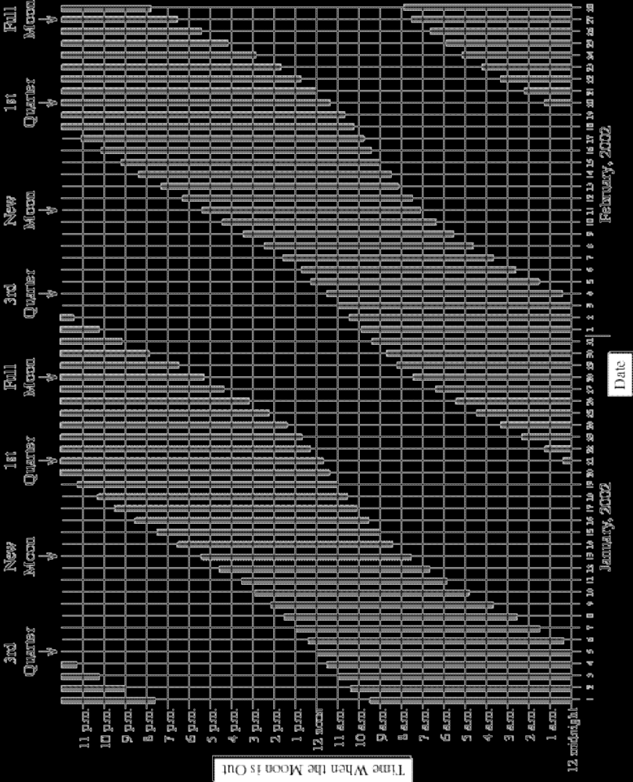

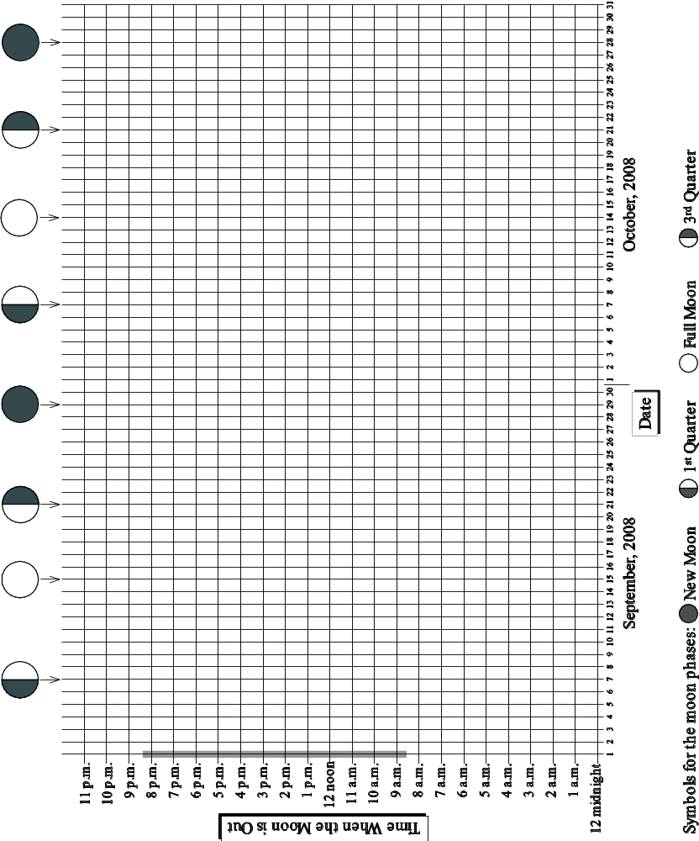

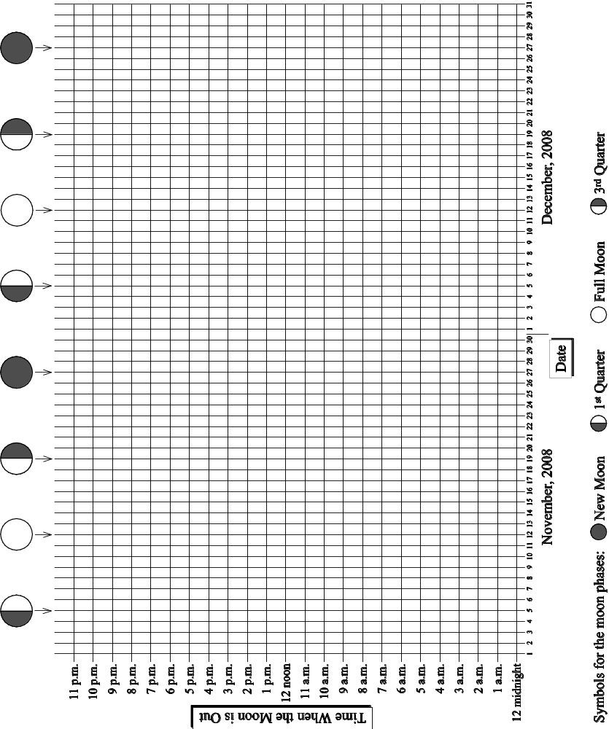

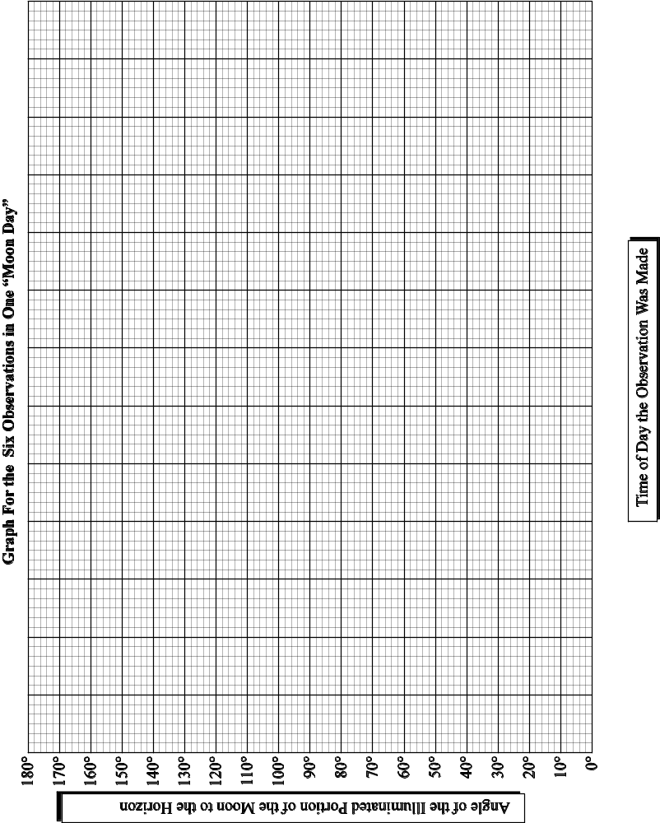

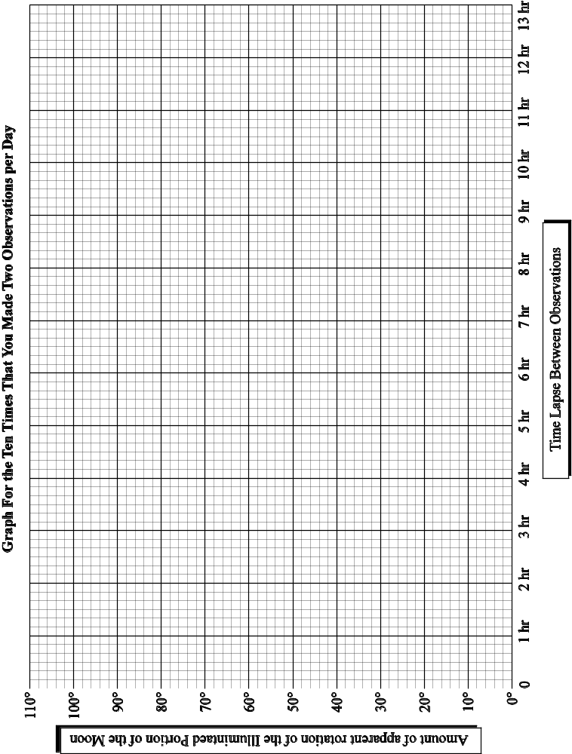

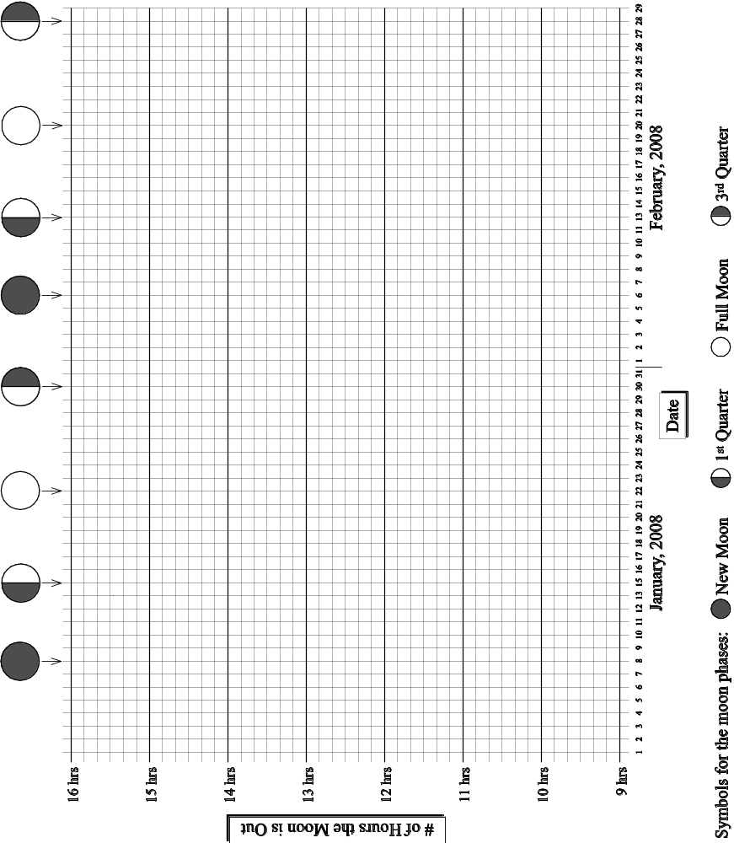

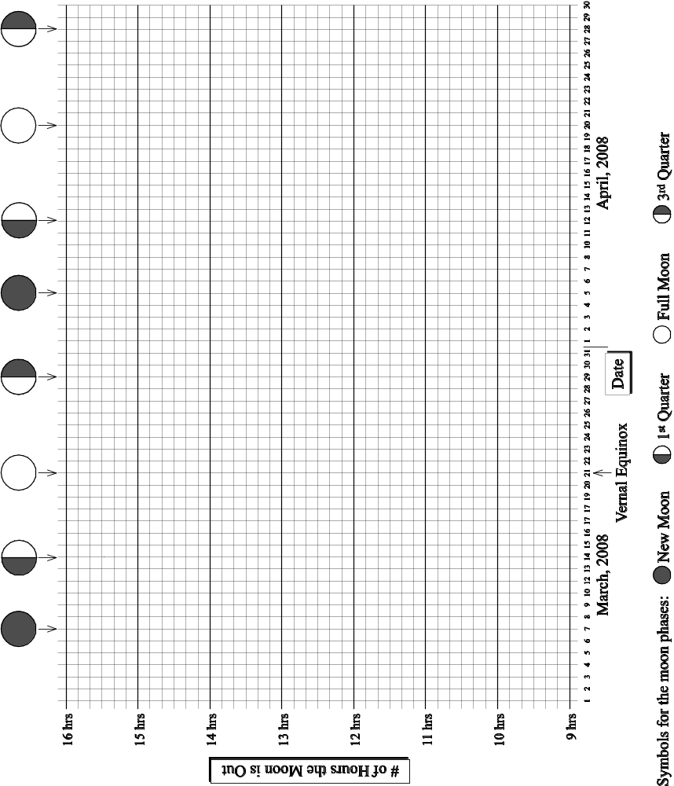

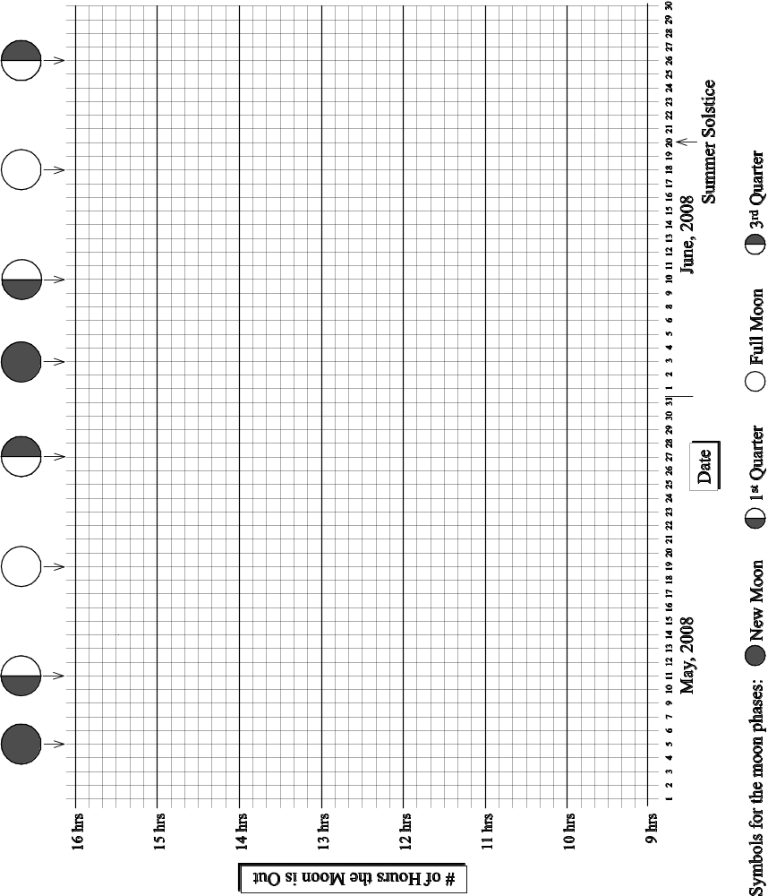

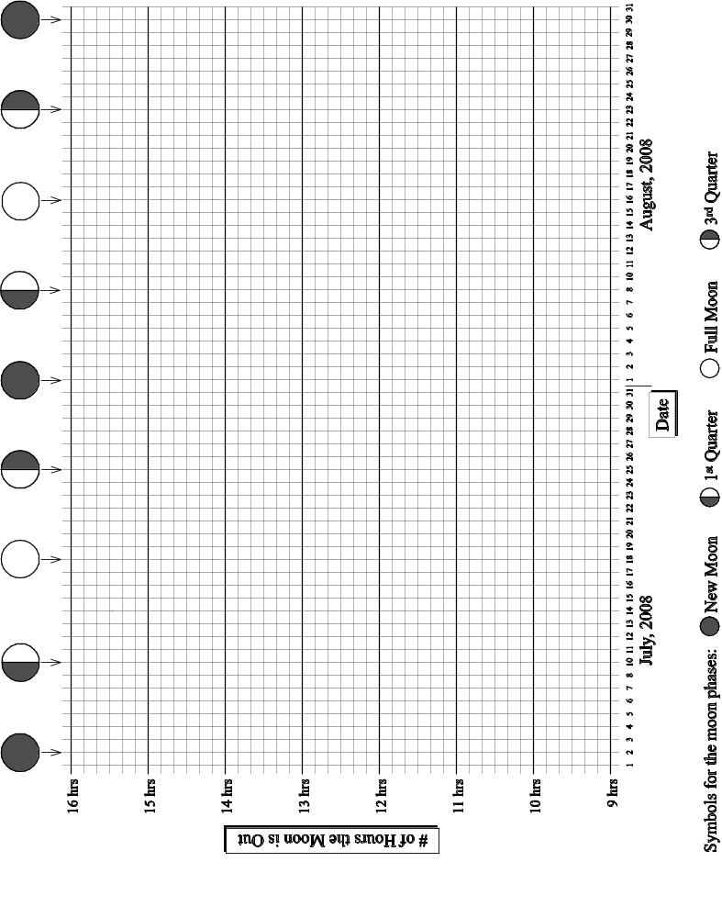

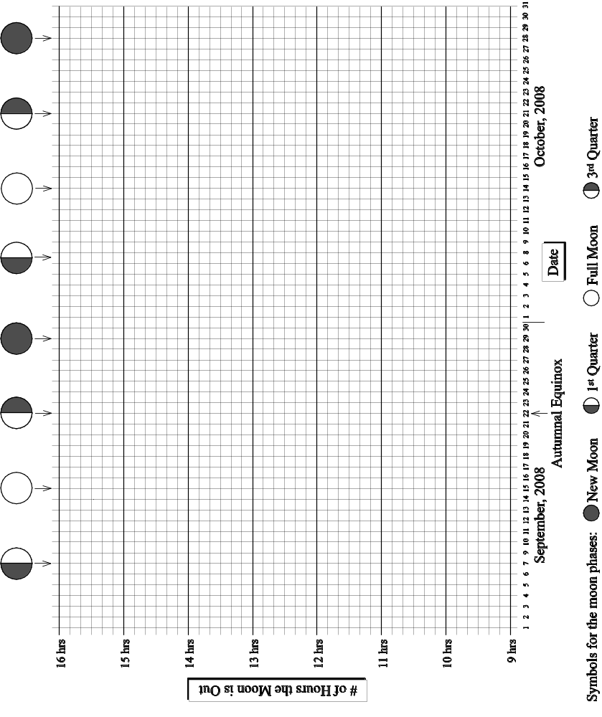

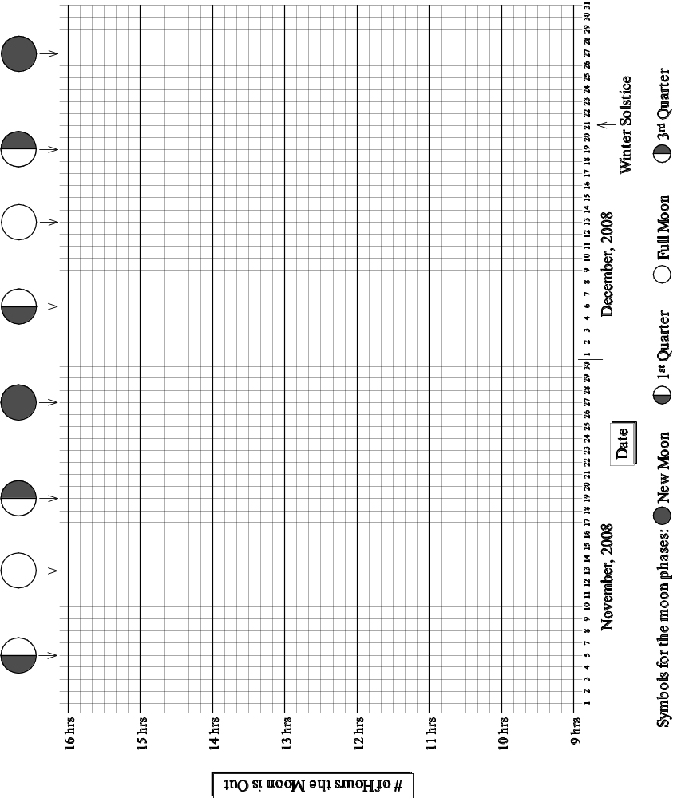

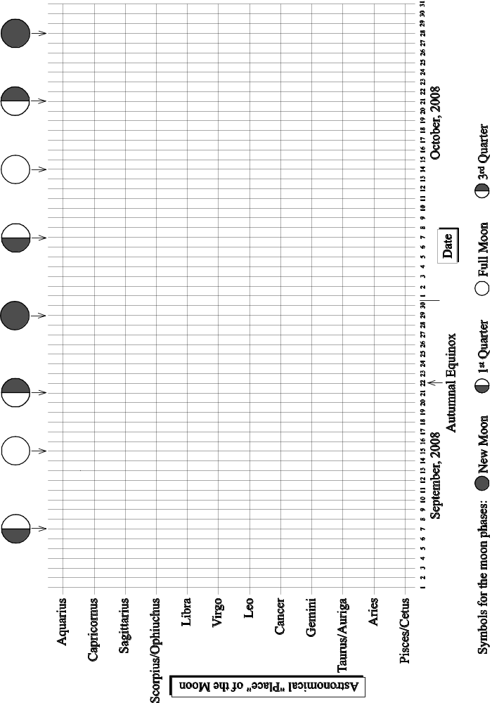

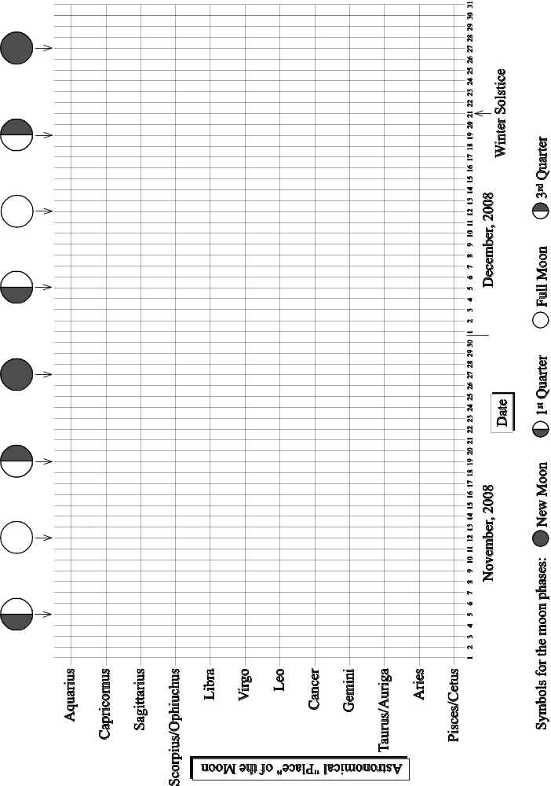

Mary Barrett is a school teacher in Berkeley, CA. This poem appeared in the Fall/Winter 1999 GEMS Network News. If you plan to teach elementary or junior high school, you absolutely need to know about GEMS (Great Explorations in Math and Science). They publish wonderful K–8 teacher’s guides in math and science. Check them out at http://www.lhs.berkeley.edu/gems/gems.html.
Please hand in the team member evaluations separately in sealed envelopes. These are for the instructor’s eyes only.
I do mean rotate, not revolve. In other words, I mean the change from a hat to a smile, not the movement of the moon across the sky (the Topic 1 folks will worry about that).
Please hand in separately in sealed envelopes. These evaluations are for your instructor’s eyes only.
See p. C–1 of your course packet for the definition of a waning moon. Word to the wise: the waning moon is easiest to see in the early morning; and it doesn't have to be dark--you can even see it during the day.
This diagram is modified from Figure 3 of the “Reckoning Latitude” experiment on p. 200 of Conceptual Physical Science Laboratory Manual (2nd edition), by Paul Hewitt, John Suchocki and Leslie Hewitt: Addison-Wesley, 1999.
Most of you plan to become teachers of children and may be wondering why we are asking you to design a lesson for adults. Here is why: (1) We want you to have the experience of teaching something that is new to the students but that is built on a foundation of previous lessons, (2) The procedure for presenting a science lesson to children is the same as the procedure for presenting a science lesson to adults, with one major exception: teachers of children must take into account the limitations of the child's incompletely developed brain. Thus it would be IMPOSSIBLE for you to design a lesson that is appropriate for children without first educating yourself on the various developmental stages of childhood--a topic that is far beyond the scope of this course.
See my lab on phases and eclipses (pages C–17 to C–26) or any other lab in the course packet to make the expectations listed here more concrete in your mind.
See my teacher’s guide for the lab you did on phases and eclipses (pages MP-27 through MP-31) to make the expectations listed here more concrete in your mind.
DON’T overlook this important step. In past semesters, many students have constructed amazingly creative manipulatives and used them in their lessons but then failed to document them in their teacher’s guides. We can’t award credit for something that isn’t documented!
Polystyrene balls cost less than $1.00 each. They are available from Molecular Model Enterprises, 116 Swift St., P.O. Box 250, Edgerton, WI 53334, (608)884-9877.
To make the expectations listed here more concrete in your mind, please see my evaluation for the lab you did on phases and eclipses (page MP-34).
 ∗ The moon does not set on this date. It sets early the next day.
** The moon does not rise on this date. It rises early the next day.

